ISO 21597-1:2019

ISO TC 59/SC 13/WG 8

Secretariat: SN

**Information container for linked document delivery – Exchange specification - Part 1: Container**

|  |
| --- |
| FDIS stage |

# 

# 

|  |
| --- |
| © ISO 2018  All rights reserved. Unless otherwise specified, or required in the context of its implementation, no part of this publication may be reproduced or utilized otherwise in any form or by any means, electronic or mechanical, including photocopying, or posting on the internet or an intranet, without prior written permission. Permission can be requested from either ISO at the address below or ISO’s member body in the country of the requester.  ISO copyright office  CP 401 • Ch. de Blandonnet 8  CH-1214 Vernier, Geneva  Phone: +41 22 749 01 11  Fax: +41 22 749 09 47  Email: copyright@iso.org  Website: www.iso.org  Published in Switzerland |

# 

# 

# Contents

Contents 2

Foreword 4

Introduction 5

1 Scope 6

2 Normative references 6

3 Terms, definitions and abbreviated terms 7

3.1 Terms and definitions 7

3.2 Abbreviated Terms 10

4 Specifications 11

4.1 Use of RDF, RDFS and OWL constructs 11

4.2 Symbols and notations 13

4.3 Container structure 16

4.3.1 Overview 16

4.3.2 “Ontology resources” folder 17

4.3.3 “Payload documents” folder 17

4.3.4 “Payload triples” folder 17

4.4 Ontologies and datasets 18

4.4.1 Overview 18

4.4.2 Container ontology 18

4.4.3 Linkset ontology 23

4.4.4 Index dataset 28

4.4.5 Link dataset 28

4.5 Versioning 28

4.6 Additional properties in datasets 30

5. Conformance requirements 30

Annex A (informative) Use cases 32

A.1 Context 32

A.2 Use case 1A – Delivery of documents 32

A.2.1 Example container - information delivery requirements 33

A.2.2 Example container - information delivery 36

A.3 Use case 1B – Delivery of documents with links 38

A.3.1 Example container - information delivery requirements 39

A.3.2 Example container - information delivery 40

Annex B (informative) Dublin Core interoperability 44

Annex C (informative) Bidirectional conversion of the ICDD container representation from RDF(S)/OWL to XSD/XML 45

https://standards.iso.org/iso/21597/-1/ed-1/en/AnnexC/xsd/Container-3.0.xsd 46

Annex D (informative) How to validate with SHACL 46

D.1 Schema extension validation 46

D.1.1 Detecting extra classes 46

D.1.2 Detecting extra predicates 47

D.2 Data validation 47

Annex E (normative) Ontologies 49

E.1 Container ontology 49

E.2 Linkset ontology 58

# 

# Foreword

ISO (the International Organization for Standardization) is a worldwide federation of national standards bodies (ISO member bodies). The work of preparing International Standards is normally carried out through ISO technical committees. Each member body interested in a subject for which a technical committee has been established has the right to be represented on that committee. International organizations, governmental and non-governmental, in liaison with ISO, also take part in the work. ISO collaborates closely with the International Electrotechnical Commission (IEC) on all matters of electrotechnical standardization.

The procedures used to develop this document and those intended for its further maintenance are described in the ISO/IEC Directives, Part 1. In particular, the different approval criteria needed for the different types of ISO documents should be noted. This document was drafted in accordance with the editorial rules of the ISO/IEC Directives, Part 2 (see [www.iso.org/directives](https://www.iso.org/directives-and-policies.html)).

Attention is drawn to the possibility that some of the elements of this document may be the subject of patent rights. ISO shall not be held responsible for identifying any or all such patent rights. Details of any patent rights identified during the development of the document will be in the Introduction and/or on the ISO list of patent declarations received (see [www.iso.org/patents](https://www.iso.org/iso-standards-and-patents.html)).

Any trade name used in this document is information given for the convenience of users and does not constitute an endorsement.

For an explanation of the voluntary nature of standards, the meaning of ISO specific terms and expressions related to conformity assessment, as well as information about ISO’s adherence to the World Trade Organization (WTO) principles in the Technical Barriers to Trade (TBT) see [www.iso.org/iso/foreword.html](https://www.iso.org/foreword-supplementary-information.html).This document was prepared by Technical Committee ISO/TC 59, *Buildings and civil engineering works*, Subcommittee SC 13, *Organization and digitization of information about buildings and civil engineering works, including building information modelling (BIM)*.

A list of all parts in the ISO 21597 series can be found on the ISO website.

Any feedback or questions on this document should be directed to the user’s national standards body. A complete listing of these bodies can be found at [www.iso.org/members.html](https://www.iso.org/members.html).

# Introduction

The ISO 21597 series has been developed in response to a recognised need within the construction industry to be able to handle multiple documents as one information delivery.

Information deliveries are often a combination of drawings, information models (representing built or natural assets in the physical world), text documents, spreadsheets, photos, videos, audiofiles, etc. Increasingly, this may also include datasets based on any ontology. An ability to specify relationships using links between information elements in those separate documents can contribute significantly to the value of an information delivery. The composition of such a package arises both from the requirements of the process, e.g. delivery of as-built information, and from the specific functional purpose e.g. performing a quantity take-off or communication about issues in 3D models.

In this part of the ISO 21597 series a specification is given for a container that stores documents, along with a means of linking otherwise disconnected data within those documents.

The container format includes a header file and optional link files that define relationships by including references to the documents, or to elements within them. The header file uniquely identifies the container and its contractual or collaborative intention. This information is defined using the RDF, RDFS and OWL semantic web standards.

The header file, along with any additional RDF(S)/OWL files or resources, forms a suite that may be directly queried by software. The link references may be interpreted by the recipient applications, or reviewed interactively by the recipient. Where it includes link references into the content of documents that don’t support standardized querying mechanisms, their resolution may depend on third party interpreters.

The format can also be used to deliver multiple versions of the same document.

**Information container for linked document delivery - Exchange specification - Part 1: Container**

# 1 Scope

This part of the ISO 21597 series defines an open and stable container format to exchange files of a heterogeneous nature in order to deliver, store and archive documents that describe an asset throughout its entire lifecycle.

It is suitable for all parties dealing with information concerning the built environment, where there is a need to exchange multiple documents and their interrelationships, either as part of the process or as contracted deliverables. The format is intended to use resources either included in the container (such as documents) or referenced remotely (such as web resources). A key feature is that the container can include information about the relationships between the documents. Relevant use-cases reflect the need for information exchange during the entire life cycle of any built asset and can include, but is not limited to, the handover of

1. a published bidding package,
2. required project deliverables at a specific project stage (e.g. when proposing different design scenarios),
3. shared information as background or for further development,
4. published approval packages, or
5. information about versions between partners to provide a means to reference particular states of the information and track changes.

# 2 Normative references

The following sources are referred to in the text in such a way that some or all of their content constitutes requirements of this document. For dated references, only the edition cited applies. For undated references, the latest edition of the referenced document (including any amendments) applies.

ISO/IEC 21320-1*, Information technology — Document Container File — Part 1: Core.* Available online at <https://standards.iso.org/ittf/PubliclyAvailableStandards/c060101_ISO_IEC_21320-1_2015.zip> [viewed Agust 5th 2019]

[IANA] Internet Assigned Numbers Authority. *Media Types*. [viewed 6 May 2019]. Available from: <https://www.iana.org/assignments/media-types/media-types.xhtml>

[W3C-OWL2-SPEC] Boris Motik, Peter F. Patel-Schneider, Bijan Parsia, eds. *OWL 2 Web Ontology Language: Structural Specification and Functional-Style Syntax (Second Edition)*. W3C Recommendation, 11 December 2012. Latest version available at <http://www.w3.org/TR/owl2-syntax/> [viewed July 22nd 2019]

[W3C-RDF11-CONCEPTS] Richard Cyganiak, David Wood, Markus Lanthaler. *RDF 1.1 Concepts and Abstract Syntax. W3C Recommendation*, 25 February 2014. Latest edition available at <http://www.w3.org/TR/rdf11-concepts/> [viewed July 22nd 2019]

[W3C-RDF11-SCHEMA] Dan Brickley, R. V. Guha. *RDF Schema 1.1*. W3C Recommendation, 25 February 2014. Latest published version available at <http://www.w3.org/TR/rdf-schema/> [viewed July 22nd 2019]

[W3C-RDF11-XML] Fabien Gandon, Guus Schreiber. *RDF 1.1 XML Syntax*. W3C Recommendation, 25 February 2014. Latest published version available at <http://www.w3.org/TR/rdf-syntax-grammar/> [viewed July 22nd 2019]

[W3C-XML-DATATYPES] David Peterson, Shudi (Sandy) Gao, Ashok Malhotra, C. M. Sperberg-McQueen, and Henry S. Thompson, eds. (Version 1.1) and Paul V. Biron, and Ashok Malhotra, eds. (Version 1.0). *W3C XML Schema Definition Language (XSD) 1.1 Part 2: Datatypes*. W3C Recommendation, 5 April 2012. Latest version available at <http://www.w3.org/TR/xmlschema11-2/> [viewed July 22nd 2019]

# 3 Terms, definitions and abbreviated terms

## 3.1 Terms and definitions

For the purpose of the ISO 21597 series, the following terms and definitions apply.

ISO and IEC maintain terminological databases for use in standardization at the following addresses:

- ISO Online browsing platform: available at <http://www.iso.org/obp>

- IEC Electropedia: available at <http://www.electropedia.org/>.

**3.1.1  
container**  
file that conforms to the ISO 21597 series

**3.1.2  
payload**primary information in the form of *documents* (3.1.3) that is included within the *container* (3.1.1)

Note to entry: this does not include the header file (Index.rdf) or the ontology resource files.

**3.1.3  
document**  
fixed and structured amount of information that can be managed and interchanged as a unit between users and systems

Note 1 to entry: This unit may not necessarily be human perceptible. Information is usually stored on a data medium.

Note 2 to entry: Used in the ISO 21597 series to refer to any document that forms part of the payload in the container, including any 2D or 3D models that represent built or natural assets in the physical world; these may be held in any standard or proprietary format.

**3.1.4  
internal document**  
*document* (3.1.3) located within the *container* (3.1.1)

**3.1.5  
external document**  
*document* (3.1.3) located outside the *container* (3.1.1)

**3.1.6  
link**  
relation between *documents* (3.1.3), including between elements in documents

**3.1.7  
ontology**  
specification of concrete or abstract things, and the relationships among them, in a prescribed domain of knowledge

Note to entry: The specification should be computer processable.

[SOURCE: W3C-OWL2-SPEC]

**3.1.8  
container ontology**  
RDF(S)/OWL file providing the object classes and properties that shall be used to specify the contents of a *container* (3.1.1)

**3.1.9  
linkset ontology**  
RDF(S)/OWL file providing the object classes and properties that shall be used to specify links between *documents* (3.1.3) in a *container* (3.1.1)

**3.1.10  
dataset**  
RDF(S)/OWL file that contains *individuals* (3.1.16) that comply with the *classes* (3.1.15) as specified by *ontologies* (3.1.7)

**3.1.11**  
**index dataset**  
RDF(S)/OWL file containing an index of the contents of the *container* (3.1.1)

**3.1.12**  
**link dataset**  
RDF(S)/OWL file containing *links* (3.1.6) as defined in the ISO 21597 series

**3.1.13**  
**serialisation**  
encoding of an *ontology* (3.1.7) or *dataset* (3.1.10) into a format that can be stored, typically in a file

[SOURCE: W3C-RDF11-XML]

**3.1.14**  
**resource**  
something in the world (the "universe of discourse") denoted by an IRI or literal

Note: Anything can be a resource, including physical things, documents, abstract concepts, numbers and strings; the term is synonymous with "entity" as it is used in the RDF Semantics specification

[SOURCE: W3C-RDF11-CONCEPTS]

**3.1.15**  
**class**  
defines a set of *individuals* (3.1.16) having the same characteristics

[SOURCE: W3C-RDF11-SCHEMA, 2.2]

**3.1.16**  
**individual**  
resource that has been placed into any RDFS *class* (3.1.15) as an instance of that class

Note 1 to entry: like RDF classes, every OWL class is associated with a set of individuals, called the class extension; the individuals in the class extension are the instances of the class.

Note 2 to entry: there are two types of individuals in the syntax of OWL 2. Named individuals are given an explicit name that can be used in any ontology to refer to the same object. Anonymous individuals do not have a global name and are thus local to the ontology in which they are contained.

[SOURCE: W3C-OWL2-SPEC, 5.6]

**3.1.17  
object property**  
OWL property that links *individuals* (3.1.16) to other individuals

[SOURCE: W3C-OWL2-SPEC, 5.3]

**3.1.18  
datatype property**  
OWL property that can relate *individuals* (3.1.16) to literals

Note 1 to entry: Literals can be strings, numbers, date types, etc.

[SOURCE: W3C-OWL2-SPEC, 5.4]

**3.1.19  
namespace**  
group of identifiers for elements and attributes that are collectively bound to a URI such that their use will not cause naming conflicts

[SOURCE: W3C-RDF11-CONCEPTS, 1]

**3.1.20  
triple**  
statement in the form *subject-predicate-object* (3.1.21, 3.1.22, 3.1.23) that expresses a relationship between two resources

[SOURCE: W3C-RDF11-CONCEPTS, 3.1]

**3.1.21  
subject**  
resource (an IRI) about which a statement is made in the form of an RDF *triple* (3.1.20)

Note to entry: This term, as used in the ISO 21597 series, is part of the RDF(S)/OWL vocabulary, where each triple consists of a subject, a predicate and an object; a set of such triples is called an RDF graph.

[SOURCE: W3C-RDF11-SCHEMA, 5.3.2]

**3.1.22  
predicate**  
the relationship between a *subject* (3.1.21) and an *object* (3.1.23) in an RDF *triple* (3.1.20), also called a property

[SOURCE: W3C-RDF11-SCHEMA, 5.3.3]

**3.1.23  
object**  
resource (either an IRI or a literal) assigned as the specified property of the *subject* (3.1.21) in a *triple* (3.1.20)

Note to entry: This term, as used in the ISO 21597 series, is part of the RDF(S)/OWL vocabulary, where each triple consists of a subject, a predicate and an object; a set of such triples is called an RDF graph.

[SOURCE: W3C-RDF11-SCHEMA, 5.3.4]

## 3.2 Abbreviated Terms

DBF DataBase File

GIS Geographic Information System

GML Geography Markup Language

GUID Globally Unique Identifier

ICDD Information Container for linked Document delivery

IFC Industry Foundation Classes

IRI Internationalized Resource Identifier

OWL Web Ontology Language

RDF Resource Description Framework

RDFS Resource Description Framework Schema

SHACL Shapes Constraint Language

SPARQL Simple Protocol And RDF Query Language

SQL Structured Query Language

UML Unified Modeling Language

URI Uniform Resource Identifier

URL Uniform Resource Locator

W3C World Wide Web Consortium

XML eXtensible Markup Language

XSD XML Schema Definition

XSLT Extensible Stylesheet Language Transformations

NOTE: IRI is an update of the URI released in 2005; while URIs are limited to a subset of the ASCII character set, IRIs can contain characters from the Universal Character Set (Unicode/ISO 10646). In the ISO 21597 series URIs and IRIs are used interchangeably.

[SOURCE: W3C-RDF11-CONCEPTS, 3.2]

# 4 Specifications

## 4.1 Use of RDF, RDFS and OWL constructs

All ontologies held in containers that conform to the ISO 21597 series shall be based on the languages RDF [W3C-RDF11-CONCEPTS], RDFS [W3C-RDF11-SCHEMA] and OWL [W3C-OWL2-SPEC] (referred to collectively in the ISO 21597 series as RDF(S)/OWL) and shall be serialised in RDF/XML [W3C-RDF11-XML].

It is expected that RDF(S)/OWL will be an important technology and a general platform for ontologies for the coming decades. Proprietary systems will increasingly adopt RDF(S)/OWL. However, in order to make the threshold for adoption of this part of the ISO 21597 series as low as possible, an informative annex (Annex C) provides specifications to support the conversion of a container from RDF(S)/OWL to XSD/XML and vice versa.

In general, when used in the context of the world wide web, these languages use the following principles to support reasoning:

* Open world assumption - the truth of a statement is independent of whether it is known. In other words, not knowing that a statement is explicitly true does not imply that the statement is false.
* No unique names assumption - unless explicitly stated otherwise, it cannot be assumed that resources that are identified by different URIs are different.

The datasets that comply with the ontologies specified in the ISO 21597 series shall use the following interpretation of RDF(S)/OWL:

* Closed world assumption - a statement that is true is also known to be true; therefore, conversely, what is not formally specified in a container to be true, is false.
* Unique naming assumption - resources in a container that are identified with different URIs are considered to be different, unless explicitly declared as the same (using the *owl:sameAs* predicate).

Table 1 lists the RDF(S)/OWL constructs that are used in the ISO 21597 series and the interpretation to be used when validating the contents of a container. It is noted that, once the contents of the container has been validated, the data can be used in an open world context.

**Table 1 - Listing of constructs used in the ISO 21597 series and their interpretation**

|  |  |
| --- | --- |
| **Construct** | **Interpretation** |
| *owl:Class* | In a dataset within a container, class membership for every individual shall be explicitly asserted, unless implicitly inferred using predicates such as *rdfs:subClassOf* [W3C-RDF11-SCHEMA, 3.4] or *owl:equivalentClass* [W3C-OWL2-SPEC, 9.1.2] |
| *rdfs:subClassOf*  *rdfs:subPropertyOf* | The ISO 21597 series does not deviate from the W3C definitions [W3C-RDF11-SCHEMA]. Statements that may be inferred due to *rdfs:subClassOf* or *rdfs:subPropertyOf* statements shall be regarded as true even if not explicitly asserted.  NOTE: statements where a class is mentioned are also true for any of its subclasses. Similarly, statements where a property is mentioned are also true for any of its sub properties. |
| *owl:FunctionalProperty* | The ISO 21597 series interprets *owl:FunctionalProperty* as a property with a maximum cardinality of 1.  [W3C-OWL2-SPEC, 9.2.4] |
| *owl:InverseFunctionalProperty* | The ISO 21597 series interprets *owl:InverseFunctionalProperty* as an inverse property with a maximum cardinality of 1.  [W3C-OWL2-SPEC, 9.2.7] |
| *owl:equivalentClass* | The ISO 21597 series does not deviate from the W3C definitions [W3C-OWL2-SPEC, 9.1.2]. Statements that may be inferred due to *owl:equivalentClass* statements shall be regarded as true even if not explicitly asserted. |
| *rdfs:range*  *rdfs:domain* | These statements shall be interpreted as restrictions. It is invalid to have a subject or object of a statement (triple) in a dataset where that individual is a member of a class that does not comply with the *rdfs:range* or *rdfs:domain* declarations of the corresponding *owl:ObjectProperty* [W3C-OWL2-SPEC, 5.3] or *owl:DatatypeProperty* [W3C-OWL2-SPEC, 5.4] |
| *owl:restriction*  *owl:onProperty*  *owl:allValuesFrom*  *owl:someValuesFrom*  *owl:hasValue*  *owl:cardinality*  *owl:minCardinality*  *owl:maxCardinality* | These statements shall be interpreted as restrictions. Any deviation from the specified restriction within a single container is considered invalid.  NOTE: as an example, if *owl:cardinality* is defined as 2, then a dataset that does not contain exactly 2 occurrences is not valid. |
| *owl:inverseOf* | The ISO 21597 series does not deviate from the W3C definitions [W3C-OWL2-SPEC, 9.2.4]. It is recommended that inverse properties are not asserted for individuals in a dataset. If they are asserted, they shall not contradict the assertions made in the opposite direction. |
| *owl:disjointUnionOf* | The expression shall be interpreted as a constraint where the subject is considered to be an abstract class in the sense that any individual member of the subject class shall also be a member of one (and only one) of the disjoint classes enumerated in the object part of the *owl:disjointUnionOf* statement. [W3C-OWL2-SPEC, 9.1.4] |

## 4.2 Symbols and notations

Throughout the ISO 21597 series, the structure of the ontologies is illustrated using a UML notation. The purpose of this subclause is to describe that notation and the meaning of the terms and symbols that are used.

Tables 2 and 3 list the namespaces and corresponding prefixes used in the ISO 21597 series.

**Table 2 - Namespaces and prefixes used in ontologies defined in the ISO 21597 series**

|  |  |  |
| --- | --- | --- |
| **Ontology** | **Prefix** | **Namespace** |
| ICDD Part 1 | icdd | [https://standards.iso.org/iso/21597/-1/ed-1/en/ICDD_P1#](https://standards.iso.org/iso/21597/-1/ed-1/en/ICDD_P1) |
| Container ontology | ct | <https://standards.iso.org/iso/21597/-1/ed-1/en/Container> |
| Linkset ontology | ls | <https://standards.iso.org/iso/21597/-1/ed-1/en/Linkset> |

**Table 3 - Namespaces and prefixes used in ontologies referenced in the ISO 21597 series**

|  |  |  |
| --- | --- | --- |
| **Ontology** | **Prefix** | **Namespace** |
| XML Schema | xsd | <https://www.w3.org/2001/XMLSchema> |
| Resource Description Framework | rdf | <https://www.w3.org/1999/02/22-rdf-syntax-ns> |
| RDF Schema | rdfs | <https://www.w3.org/2000/01/rdf-schema> |
| Web Ontology Language | owl | <https://www.w3.org/2002/07/owl> |

Figure 1 illustrates the UML notations used in the ISO 21597 series to render classes and properties.

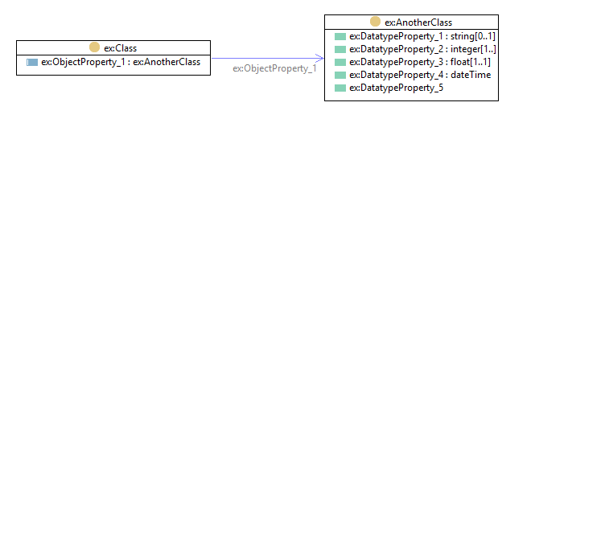

**Figure 1 - UML notation for classes and properties**

A class (*owl:Class*) is illustrated by a rectangular box with two compartments as shown in Figure 1. In the upper compartment, the class name (“*ex:Class*” in Figure 1) is displayed. Note that the class name is shown following the pattern “*prefix:ClassName”*, where the prefix (“ex” in the example) denotes namespace of the ontology and “ClassName” is the name of the class. The prefixes actually used in the ISO 21597 series are defined in Tables 2 & 3 above.

The lower compartment shows the specified properties for that class. There are two general types of properties:

* Datatype properties are those for which the value is a data literal, as illustrated for *ex:AnotherClass* in Figure 1; and
* Object properties, for which the value is an individual; e.g. *ex:Class* in Figure 1, where the property *ex:ObjectProperty_1* references an individual of class *ex:AnotherClass*.

The property definitions are shown according to the pattern “*prefix:propertyName: range[cardinality]”*. The range of a datatype property shall be based on one of the predefined data types in XML schema [W3C-XML-DATATYPES]. The range of an object property is usually one of the classes occurring in the ontology but may also refer to a class in another ontology.

If classes on both sides (domain and range) of an object property are visible in a diagram, the object property may also be illustrated with an (blue) arrow between the classes pointing from the domain class towards the range class (as shown in Figure 1). The name of the object property is displayed along the arrow as well as in the property compartment of the class box as explained above.

Any cardinality restrictions are displayed within square brackets using the following notation: *[minCardinality..maxCardinality]*, where *minCardinality* specifies the minimum allowed occurrences and *maxCardinality* specifies the maximum allowed number of occurrences

The cardinality restrictions shall be interpreted in the following fashion:

* omitted - no cardinality restriction exists, i.e. any number of occurrences from zero to many are allowed;
* *maxCardinality* omitted (e.g. [0..], [1..] etc) - maximum cardinality is unrestricted.

If two classes are related using an *rdfs:subClassOf* predicate, this is rendered using an arrow as shown in Figure 2. This diagram illustrates that *ex:SubClass* and *ex:Class* are related using an *rdfs:subClassOf* predicate.

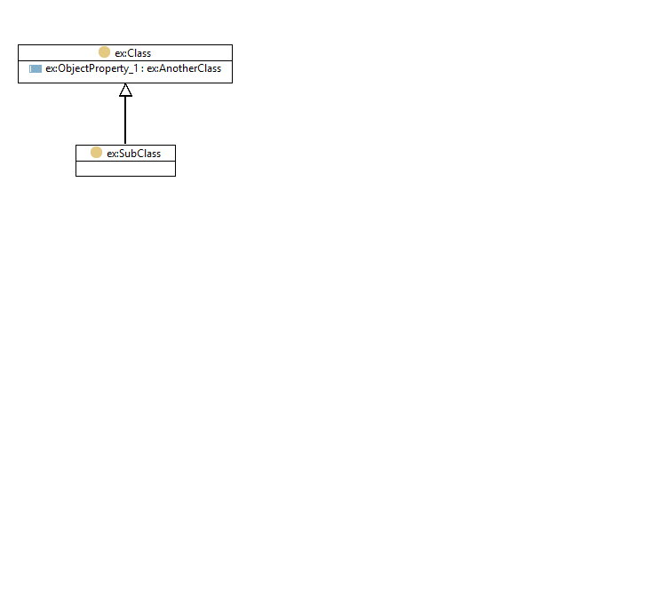

**Figure 2 - Depiction of a sub-class relationship**

Disjoint classes are illustrated in Figure 3.

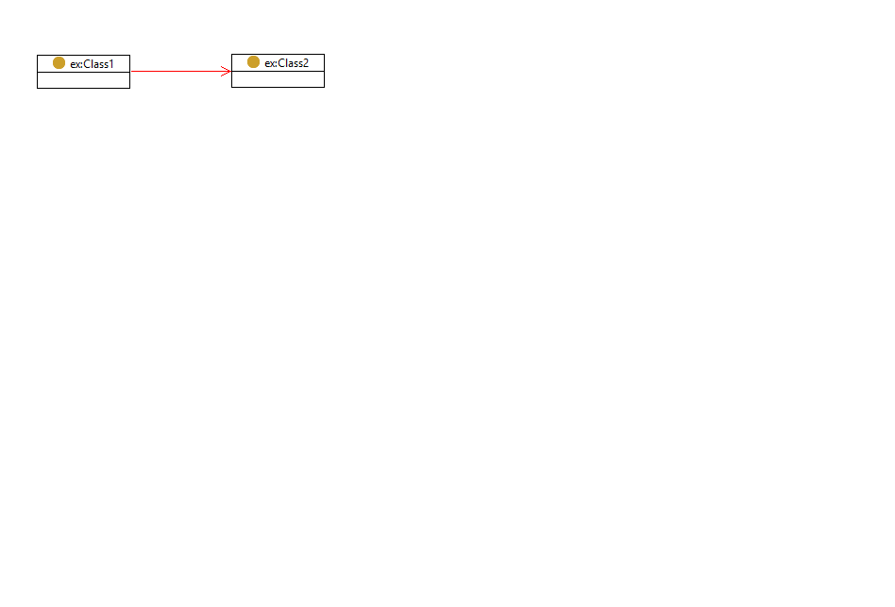

**Figure 3 - Depiction of disjoint classes**

The red arrow pointing from *ex:Class1* to *ex:Class2* declares that they are disjoint, meaning that an instance is not allowed to be a member of both *ex:Class1* and *ex:Class2*. This is declared with an *owl:disjointUnionOf* statement (*ex:Class1 owl:disjointUnionOf ex:Class2*). The *owl:disjointUnionOf* property is symmetric, meaning that if Class1 is disjoint with Class2, then Class2 is also disjoint with Class1.

Two classes which are declared as equivalent by the use of *owl:equivalentClass* (e.g. *ex:Class3 owl:equivalentClass ex:Class4*) are depicted as shown in Figure 4.

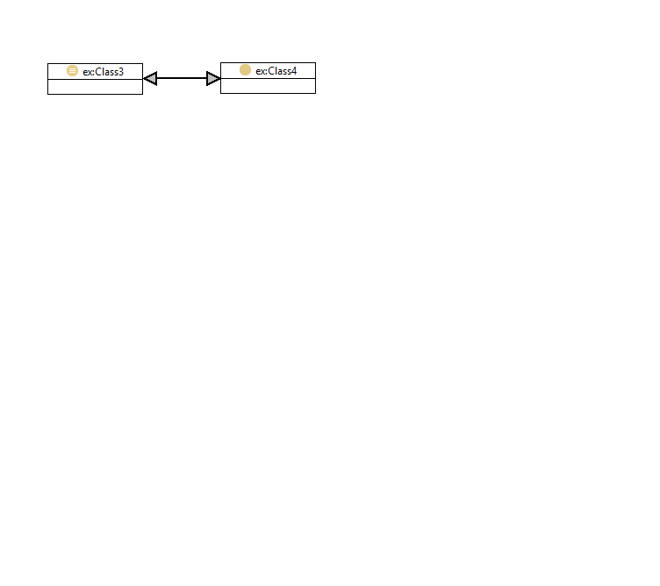

**Figure 4 - Depiction of equivalent classes**

Finally, a class may be both the *Domain* and *Range* for a certain *ObjectProperty*. Such a relationship is rendered as shown in Figure 5, i.e. with the little arrow aligned to the bottom of the Class box without any label attached to the arrow.

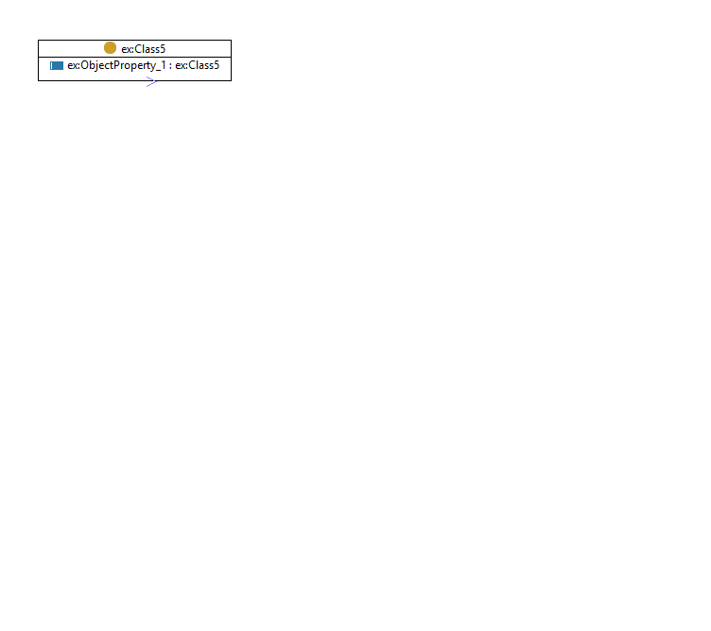

**Figure 5 - Depiction of an ObjectProperty defined by an individual of the same class**

## 4.3 Container structure

### 4.3.1 Overview

A container is a file that shall have an extension “.icdd” and shall comply with ISO/IEC 21320-1 also known as ZIP64.

A container includes a header file in the top-level folder; this file shall comply with the RDF(S)/OWL standards and shall be serialized in RDF/XML [W3C-RDF11-XML] . The name of this header file is Index.rdf.

As a minimum, a container shall have at least three folders as illustrated in Figure 6. The purpose of these top-level folders is explained in the following subclauses. The “Payload documents” folder and “Payload triples” folder may contain nested folders to allow groups of associated digital resources to be held together and referenced as a group (e.g. a building information model with its associated reference files or a set of linked spreadsheets).

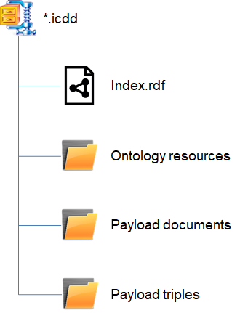

**Figure 6 - Minimum structure of the root of a container**

Figure 7 shows the hierarchy of folders and files within a container.

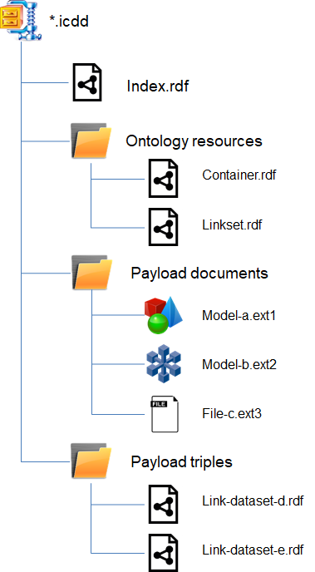

**Figure 7 - Hierarchy of folders and files in a container**

### 4.3.2 “Ontology resources” folder

The “Ontology resources” folder can be used to store the Linkset.rdf and Container.rdf ontologies that together provide the object classes and properties that shall be used to specify the contents of and links between the documents within the container. These ontologies shall be serialised in the RDF/XML format [W3C-RDF11-XML]. Since they are both available as online resources, it is not mandatory to include them here, but if included, the files in this folder shall take precedence.

### 4.3.3 “Payload documents” folder

The “Payload documents” folder shall be used for storing all the documents that are included in the container (referred to as the payload). Sub-folders are allowed.

### 4.3.4 “Payload triples” folder

The “Payload triples” folder shall be used for storing Linkset files and may include sub-folders.

## 4.4 Ontologies and datasets

### 4.4.1 Overview

Using RDF(S)/OWL technology, the object classes and properties that are used to specify the contents of and links between the documents within the container is specified within the container using two ontologies:

* Container ontology, available online via <https://standards.iso.org/iso/21597/-1/ed-1/en/Container>.
* Linkset ontology, available online via <https://standards.iso.org/iso/21597/-1/ed-1/en/Linkset>.

As noted previously, these ontologies can be included in the container in the “Ontology resources” folder to create a self-contained container that may be used off-line or for archiving purposes. Since these ontologies conform to the ISO 21597 series, they shall not be modified in any way.

In addition, the container shall include RDF(S)/OWL datasets that describe the contents of the container and the links between those documents. We distinguish two types of datasets. First, the container shall include one Index dataset, called Index.rdf and held in the root of the container; it is used to describe the container and to specify the documents that make up its contents. Second, the container may include zero or more Link datasets, used to specify the link relationships among documents. All such datasets shall reference the Container and Linkset ontologies.

The Container and Linkset ontologies are described in the following two subclauses, with the RDF(S)/OWL source included in the normative Annex E. The two types of dataset described in the previous paragraph are then described in 4.4.4 and 4.4.5 respectively.

### 4.4.2 Container ontology

The Container ontology is an RDF(S)/OWL file containing definitions of the classes and properties used in an Index dataset, providing metadata about the container.

The Index dataset enables the specification of:

* Version of ICDD standard via the import of the reference ontology
* List of external documents with metadata
  + mandatory file name (including a URI or IRI)
  + optional format
  + optional description
* List of internal documents with metadata
  + mandatory file name (including its path in the container folder structure)
  + optional format
  + optional description
* Reference to Link datasets

Tables 4, 5 and 6 list the objects, datatype properties and object properties respectively that are used in the Container ontology, providing brief descriptions of each.

**Table 4 - Classes defined in the Container ontology**

|  |  |
| --- | --- |
| **Object Name** | **Description** |
| *ct:ContainerDescription* | a description for a container where all documents are listed and where Link datasets can be found. There shall be exactly one *ct:ContainerDescription* instance in any container. |
| *ct:EncryptedDocument* | a reference to an encrypted document |
| *ct:ExternalDocument* | a reference to a document outside a container |
| *ct:InternalDocument* | a reference to a document inside a container |
| *ct:Linkset* | a reference to an RDF(S)/OWL file containing links |
| *ct:Document* | an abstract class for references to a document; an individual shall be a member of *ct:ExternalDocument* or *ct:InternalDocument*; and optionally, individuals may also be a member of other subtypes of *ct:Document* such as *ct:SecuredDocument* and/or *ct:EncryptedDocument* |
| *ct:SecuredDocument* | a document secured by a checksum algorithm (see also properties *ct:checksum* and *ct:checksumAlgorithm*) |
| *ct:FolderDocument* | a document comprising multiple files located in one folder, such as a GIS dataset consisting SHP files with associated DBF files |
| *ct:Party* | an abstract class that represents the generalization of a *ct:Organisation* or a *ct:Person*; entities can refer to an individual of a subclass of *ct:Party* via the *ct:creator*, *ct:modifier* or *ct:publisher* object properties |
| *ct:Person* | a class representing a person for provenance purposes |
| *ct:Organisation* | a class representing an organisation for provenance purposes |

**Table 5 - Datatype properties used in the Container ontology**

|  |  |
| --- | --- |
| **Datatype Name** | **Description** |
| *ct:checksum* | a checksum hash for the document reference; the checksum algorithm is specified by the property *ct:checksumAlgorithm* |
| *ct:checksumAlgorithm* | the algorithm used to generate the checksum hash |
| *ct:conformanceIndicator* | a string-based indicator for *ct:ContainerDescription* to show to which part of the ISO 21597 series this container conforms: for a Part 1 container, the value should be set to "ICDD-Part1-Container"; the range is not restricted to allow other indicator values |
| *ct:creationDate* | the creation date as *xsd:dateTime* |
| *ct:description* | a general description |
| *ct:encryptionAlgorithm* | optional string describing the encryption |
| *ct:filename* | the file name of a *ct:Linkset* or *ct:InternalDocument*; the root corresponds with the payload-documents folder of the ICDD container; the forward slash character ("/") shall be used as a folder separator.  NOTE: An example of a *ct:filename* is “IFC Models/MyFile_1.ifc” which refers to the file MyFile_1.ifc inside the folder IFC Models inside the Payload documents folder in the container. |
| *ct:foldername* | a folder name for specifying a folder where a multi file document can be found; the root corresponds with the payload-documents folder of the ICDD container; the forward slash character ("/") shall be used as a folder separator.  NOTE: An example of a *ct:foldername* is “GIS Datasets/Terrain” which refers to the folder Terrain inside folder GIS Datasets inside the Payload documents folder in the container. |
| *ct:filetype* | a string that specifies the file type such as "GML", "IFC", "shp", "xlsx", "pdf","rvt"; the string may be a compound string to indicate version and data format (e.g. “ifc-4-xml-zip”) |
| *ct:format* | the media-type of a document shall follow the specification by the Internet Assigned Numbers Authority [IANA]; examples are “application/pdf” and “audio/mpeg” |
| *ct:modificationDate* | the modification date as *xsd:dateTime* |
| *ct:name* | a name for a document  NOTE: An example of a *ct:name* is “D101” |
| *ct:requested* | a boolean to indicate whether a document is required or not.; when this property is not set the value can be interpreted as “false” |
| *ct:url* | the URL where the external document can be found |
| *ct:userID* | The user defined identifier |
| *ct:versionDescription* | an optional character string that may be used to provide a description for a version of the corresponding resource |
| *ct:versionID* | an optional character string that may be used to identify a version of the corresponding resource |

**Table 6 - Object properties used in the Container ontology**

|  |  |
| --- | --- |
| **Object Property Name** | **Description** |
| *ct:createdBy* | a reference to a creator of this instance which can only be a subclass of *ct:Party*  Inverse property: *ct:created* |
| *ct:modifiedBy* | a reference to the modifier of this instance which can only be a subclass of *ct:Party*  Inverse property: *ct:modified* |
| *ct:publishedBy* | the party responsible for making the container available  Inverse property: *ct:published* |
| *ct:alternativeDocument* | a property to link a document to an alternative version of that document  Inverse property: *ct:alternativeTo* |
| *ct:belongsToContainer* | a owl property defining the relation between a document reference and a container |
| *ct:containsLinkset* | a relation from a *ct:ContainerDescription* to a *ct:Linkset* reference. Multiple linkset references are allowed.  Inverse property: *ct:containedInContainer* |
| *ct:containsDocument* | a relation from *ct:ContainerDescription* to a document reference. Relations to multiple document references are allowed. |
| *ct:priorVersion* | an optional reference to the prior version of this resource  Inverse property: *ct:nextVersion* |

Figure 8 illustrates the context of the Container ontology, showing the structure of a container and the meta-information associated with it. The *ct:ContainerDescription* class is a subclass of the *owl:Ontology* class (more information on *owl:Ontology* can be found in section 3 of the OWL 2 Web Ontology Language Structural Specification and Functional-Style Syntax [W3C-OWL2-SPEC]). Each ontology is an individual that is a member of the *owl:Ontology*.

The Index dataset of a container declares an individual that is a type of *ct:ContainerDescription* and thus also a member of the class *owl:Ontology*. The IRI or URI of this individual is used as the identifier for the Index dataset and consequently can be used to identify the container. The Index dataset imports the Container ontology via *owl:import* property, so that the individual inherits a *ct:description* property and mandatory *ct:publisher* object property referring to a *ct:Party*. It also refers to individuals of classes *ct:Linkset* and *ct:Document* via the object properties *ct:containsLinkset* and *ct:containsDocument* respectively, in that way defining the structure of the container.

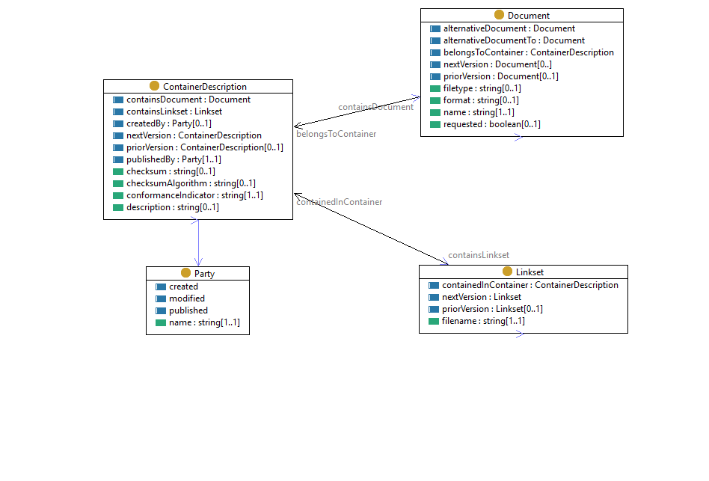

**Figure 8 - *ct:ContainerDescription* context**

Figure 9 illustrates the properties and sub-classes of documents supported in a container that conforms to the ISO 21597 series. All documents shall have a *ct:name* and optionally *ct:filetype*, *ct:format* and *ct:requested* properties (the latter being a boolean to indicate that the document is requested from the recipient of the container). Individuals of class *ct:Document* shall be typed as either a *ct:InternalDocument* or *ct:ExternalDocument* (enforced by an *owl:disjointUnionOf* statement interpreted as a restriction). The figure shows additional subclasses of *ct:Document* that may be used to declare encrypted, secure or folder documents.

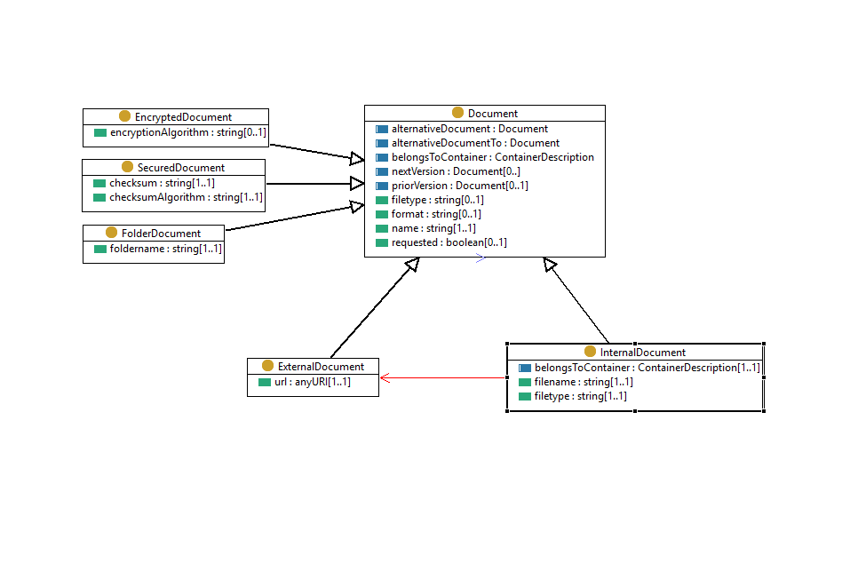

**Figure 9 - *ct:Document* context**

Subject to which subtypes are specified, new properties are available or are mandatory. Multiple typing of documents is allowed unless an *owl:disjoint* statement between these classes is present. A *ct:FolderDocument* represents a document that is present in a folder and may comprise multiple files. A *ct:EncrypedDocument* class is used to state that a document is encrypted. A *ct:SecuredDocument* can be used when a document is secured by a hash using an algorithm such as for example SHA256.

### 4.4.3 Linkset ontology

The Linkset ontology is an RDF(S)/OWL file that provides the object classes and properties that shall be used to create a Link dataset. A Link dataset specifies the linkages among documents and re-uses the document descriptions from the Index dataset, and therefore shall import the Index dataset.

A Link can specify interdependencies among two or more documents as well as among elements contained in these documents. Most typical applications of Links are linkages:

* between a single element and a related document (e.g. a row in a spreadsheet and a GML file);
* between one element in one document and multiple related elements in other documents (e.g. a catalogue element and the occurrences in a building model);
* among a set of elements in one document and related elements in multiple documents (e.g. a group columns and the corresponding specification items in a bill of quantity and the processes in schedule document).

To identify certain elements within a document, this part of the ISO 21597 series provides three general mechanisms: a string-based identifier; a query; or a URL-based identifier. The choice of the element attributes used and syntax of identifiers and queries is left up to implementers.

Tables 7, 8 and 9 list the objects, datatype properties and object properties respectively that are used in the Linkset ontology, providing brief descriptions of each.

**Table 7 - Classes defined in the Linkset ontology**

|  |  |
| --- | --- |
| **Object Name** | **Description** |
| *ls:BinaryLink* | An *ls:Link* comprising exactly 2 individuals of class *ls:LinkElement* |
| *ls:DirectedLink* | An *ls:Link* that uses the subproperties *ls:hasFromLinkElement* and *ls:hasToLinkElement* to denote a direction of this link |
| *ls:DirectedBinaryLink* | A subtype of a binary link (that has exactly 2 instances of *ls:LinkElement*) that uses the subproperties *ls:hasFromLinkElement* and *ls:hasToLinkElement* to denote a direction of this link |
| *ls:Directed1toNLink* | A subtype of *ls:DirectedLink* mandating exactly 1 *ls:hasFromLinkElement* |
| *ls:Identifier* | An abstract class for identifying an element within a document; in cases where an identifier may be computed, this shall be managed by the implementer since no method is specified in the ISO 21597 series  *ls:Identifier* is the union of its disjoint subclasses *ls:StringBasedIdentifier*, *ls:URLBasedIdentifier* and *ls:QueryBasedIdentifier*. Considering the *owl:disjointUnionOf* constraint definition (see Table 1), any individual member of this class shall be a member of one and only one of its subclasses. |
| *ls:Link* | A grouping of 1 or more instances of *ls:LinkElement* |
| *ls:LinkElement* | A class for referencing to a document or to an element in a document |
| *ls:QueryBasedIdentifier* | An identifier of an element in a document based upon a query |
| *ls:StringBasedIdentifier* | Identification of an element within a document via a String ID |
| *ls:URIBasedIdentifier* | URI/IRI-based identifier for a document, or element within a document, that is located on the web |

**Table 8 - Datatype properties defined in the Linkset ontology**

|  |  |
| --- | --- |
| **Datatype Name** | **Description** |
| *ls:identifier* | A datatype String property containing the actual ID string |
| *ls:identifierField* | A String datatype for defining the field(s) where the identifier can be found; in cases where the identifier is composed of multiple fields, the implementer shall choose the syntax rules |
| *ls:queryExpression* | The query resulting in an identifier |
| *ls:queryLanguage* | A query language specification |
| *ls:uri* | A URI/IRI for referring to a document |

**Table 9 - Object properties defined in the Linkset ontology**

|  |  |
| --- | --- |
| **Objecttype Name** | **Description** |
| *ls:hasIdentifier* | A relation from *ls:LinkElement* to an *ls:Identifier* |
| *ls:hasLinkElement* | A relation from an *ls:Link* to an *ls:LinkElement* |
| *ls:hasFromLinkElement* | A relation from an *ls:Link* to an *ls:LinkElement*. It is a sub property of *ls:hasLinkElement* |
| *ls:hasToLinkElement* | A relation to an *ls:Link* from an *ls:LinkElement*. It is a sub property of *ls:hasLinkElement* |
| *ls:hasDocument* | A relation from a *ls:LinkElement* to a *ct:Document* |

Figure 10 shows the basic structure for an *ls:Link* dataset.

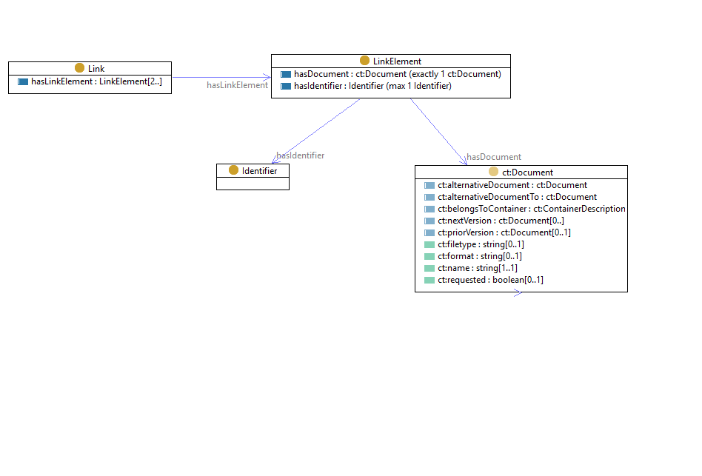

**Figure 10 - *ls:Link* context**

An *ls:Link* has at least 2 instances of *ls:LinkElement* (*ls:hasLinkElement*). An *ls:LinkElement* references a *ct:Document* (*ls:hasDocument*) and optionally an identifier (*ls:hasIdentifier*). The identifier reference is necessary for deep linking, i.e. referencing individual elements within a *ct:Document* and is explained further in Figure 11.

*ls:Link* has subclasses *ls:BinaryLink* and *ls:DirectedLink*.

Figure 11 shows the structure for *ls:BinaryLink*, with exactly two instances of *ls:LinkElement* via the *ls:hasLinkElement* property. Furthermore, an *ls:DirectedBinaryLink* is defined as a subclass of *ls:BinaryLink* with mandatory properties *ls:hasFromLinkElement* and *ls:hasToLinkElement*. These properties are subproperties of *ls:hasLinkElement*. An *ls:DirectedBinaryLink* is a subclass of both *ls:BinaryLink* and *ls:DirectedLink*, inheriting all restrictions.

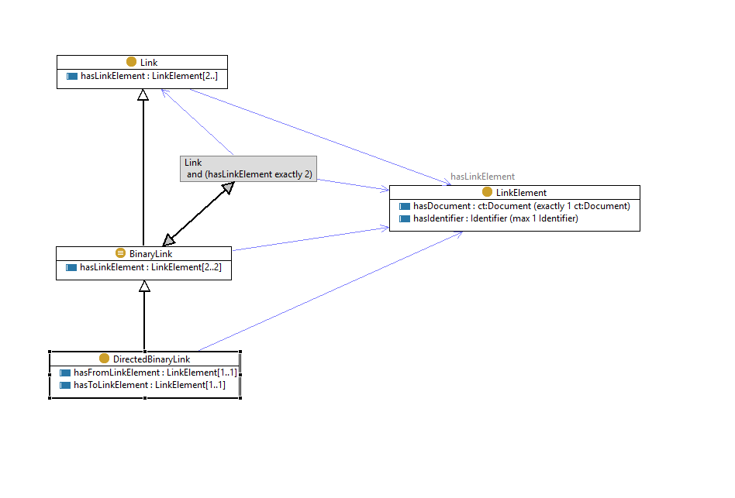

**Figure 11 - *ls:BinaryLink* context**

Figure 12 shows the structure for *ls:DirectedLink*, i.e. a relationship where the direction of the relationship is significant. Here an *ls:Directed1toNLink* is defined as a subclass of *ls:DirectedLink* with an additional “exactly 1” restriction on *ls:hasFromLinkElement* property.

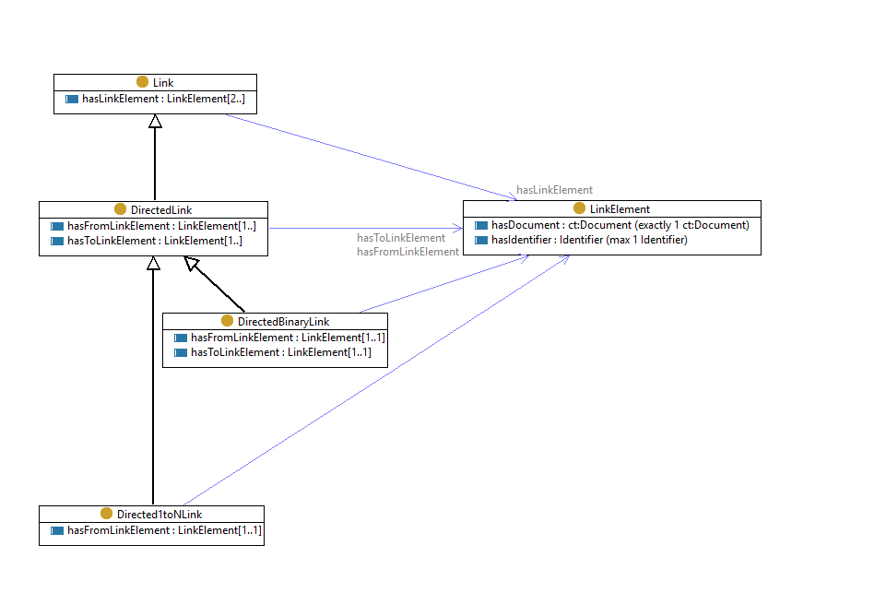

**Figure 12 - *ls:DirectedLink* context**

Figure 13 shows the objects and properties for *ls:Identifier*.

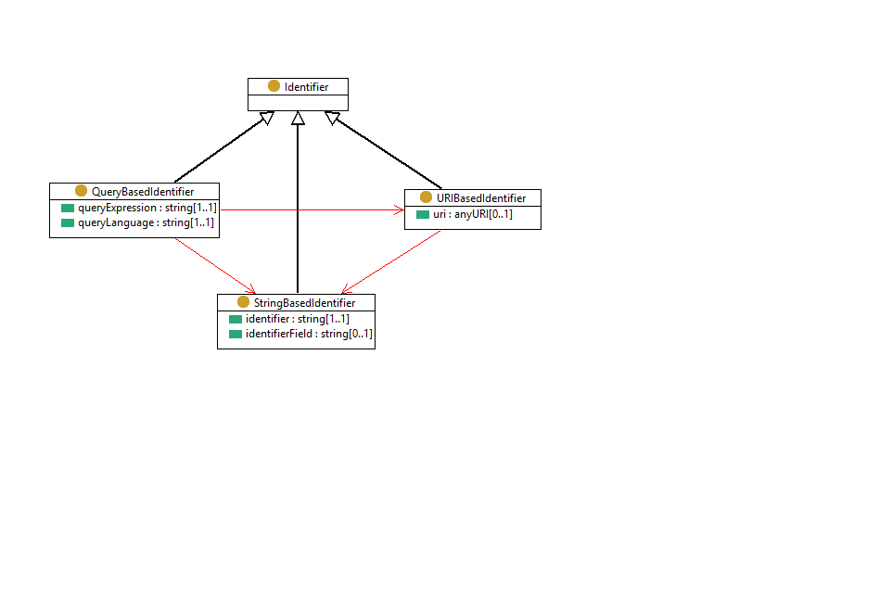

**Figure 13 - *ls:Identifier* context**

*ls:Identifier* is the union of its disjoint subclasses *ls:StringBasedIdentifier*, *ls:URLBasedIdentifier* and *ls:QueryBasedIdentifier*. In the ISO 21597 series, this is interpreted as a constraint, having the effect of making *ls:Identifier* an abstract superclass that shall be realised through one of those three subclasses.

The *ls:StringBasedIdentifier* has a mandatory *ls:Identifier* data type (*xsd:string*) for the actual ID. The optional *ls:identifierField* can be used to supply extra information about the field, such as where to find the ID.

The *ls:URLBasedIdentifier* can be used to refer to a document or an element within a document using an *xsd:anyUri* via the *ls:url* datatype property.

The *ls:QueryBasedIdentifier* has a mandatory *ls:queryExpression* datatype property, a mandatory *ls:queryLanguage* datatype property and an optional *ls:querySortExpression*. An SQL query (such as “Select ID from table where Country=‘Mexico’”) could be the input for the *ls:queryExpression* and “SQL” could be the query language. Alternatively an XQuery (such as “for $x in doc("costestimation.xml")/foundation/objects where $x/price>30 order by $x/id return $x/id”) could be the input the *ls:queryExpression*, “Xquery” could be the query language.

### 4.4.4 Index dataset

A container shall have one Index dataset called Index.rdf. The Index dataset shall reside in the root of the container.

The Index dataset shall import the Container ontology via *owl:import* statement in the *owl:Ontology* resource. The *owl:Ontology* individual within this graph will be typed as a *ct:ContainerDescription* and its properties can be filled in. Individuals of *ct:Document* can be attached to this description according to the Container ontology. Each individual of a *ct:Document* describes a document. In case of an internal document a reference to its location in the Payload documents folder is mandatory.

### 4.4.5 Link dataset

Any Link dataset(s) included in the container shall reside in the “Payload triples” folder and shall import at least Index.rdf and the Linkset ontology. It contains all the links between documents as individuals of *ls:Link* and *ls:LinkElement* according to the Linkset ontology.

## 4.5 Versioning

The purpose of versioning within the ISO 21597 series is to enable the following functionalities:

* enable the delivery of various alternative solutions in one container (e.g. when proposing different design scenarios);
* enable transfer of the history of resources;
* enable exchange of information about versions between partners to provide a means to reference particular states of the information;
* enabling tracing of previous versions.

Versioning is handled by adding versioning properties to the ontologies and restricting them to certain domains and ranges.

The following subjects may be versioned:

* an individual which is a member of class *ct:ContainerDescription* as specified in the Container ontology; version information at this level, if provided, specifies a version for the container as a whole;
* an individual which is a member of class *ct:Document* as specified in the Container ontology; version information at this level, if provided, specifies a version for the referenced document;
* an individual which is a member of *ct:Linkset* as specified in the Container ontology; version information at this level specifies a version for a particular linkset.

If a resource is versioned, the property *ct:versionID* shall be used to indicate the version of the resource and the corresponding property *ct:versionDescription* may be used to include a clarifying description of the version. This property is declared as functional and only one value is allowed. The *ct:versionID* property shall have the range *xsd:string*. The ISO 21597 series does not prescribe any particular formatting of the character string for the content of version identification, leaving that up to the user.

To enable tracking of version history for resources, a versioned resource may, besides *ct:versionID*, indicate a prior version using the property *ct:priorVersion*. The object of a *ct:priorVersion* predicate shall have the same type as its subject.

Note: Versioning of data elements inside particular documents of particular formats (e.g. ENTITY instances in .ifc-files) is out of scope for the ISO 21597 series.

Figure 14 provides an example dataset with version information.

* An Index dataset, version 1.3, which references a prior version of the same container
* The container references a number of Link datasets and individuals of class *ct:InternalDocument*
* Two Link datasets, where one Link dataset is the *ct:priorVersion* of the other Link dataset
* Three Documents: two IFC documents where one is the *ct:priorVersion* of the other; one spreadsheet document referencing its *ct:priorVersion* (not present in this container)

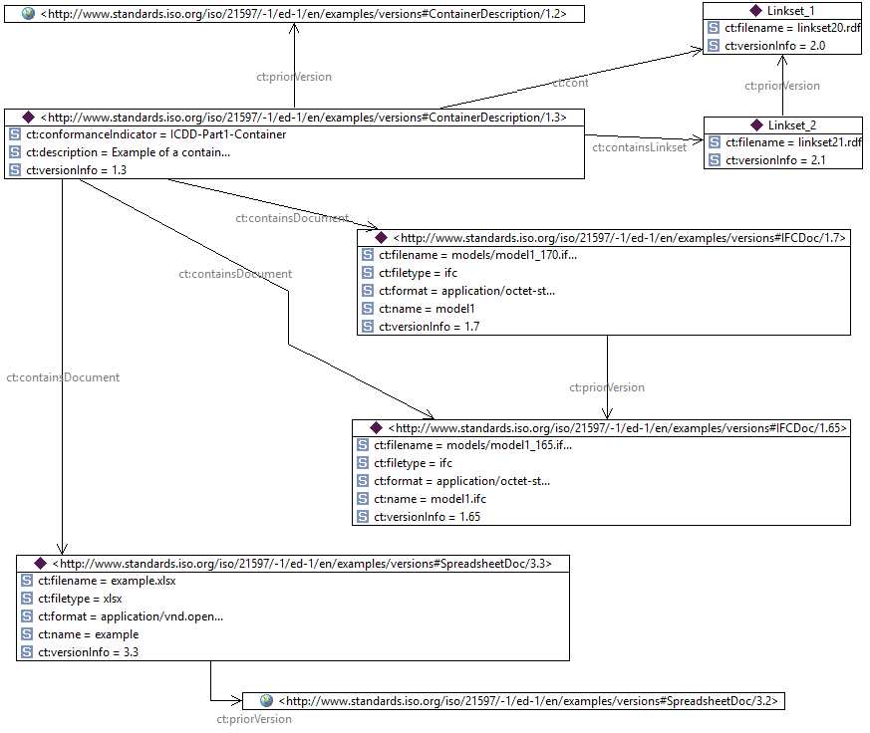

**Figure 14 - Example data with version information**

## 4.6 Additional properties in datasets

Individuals in a dataset shall only be members of classes defined in the ISO 21597 series. However, it is permitted to use other predicates defined outside of the Container or Linkset namespaces to define additional properties. These predicates and their objects can be used to exchange additional information for individuals in the datasets.

The object can be a literal or a URI. This document prescribes no further interpretation of these additional properties and consequently each shall be handled as a key-value pair. Use case 1B in Annex A includes an example of an additional property.

# 5. Conformance requirements

Any container file which is claimed to be in conformance with this part of the ISO 21597 series shall satisfy all requirements in this clause.

The following requirements apply for the container:

1. The Container shall be a valid Zip64 file.
2. The Container shall have an Index.rdf file in the root.
3. The container shall have the following folders:
   1. “Ontology resources”;
   2. “Payload documents”;
   3. “Payload triples”.
4. If the ontology file Container.rdf and/or Linkset.rdf is included in the container, then it shall be located in the “Ontology resources” folder.
5. The Container shall have the “.icdd” filename extension.

The following requirements apply for the Index.rdf file:

1. It shall comply with RDF(S)/OWL.
2. It shall be serialised in RDF/XML [W3C-RDF11-XML].
3. It shall comply with the Container.rdf file as specified in this part of the ISO 21597 series.
4. It shall import the Container.rdf ontology using *owl:import* predicate.
5. It shall list all internal documents and external documents.
6. It shall list all datasets.
7. It shall contain the value “ICDD-Part1-Container” for the *ct:conformanceIndicator* property.

The following requirements apply for every Link dataset file:

1. It shall comply with RDF(S)/OWL.
2. It shall be serialised in RDF/XML [W3C-RDF11-XML].
3. It shall comply with the Linkset.rdf ontology as specified in this part of the ISO 21597 series.
4. It shall be stored in the “Payload triples” folder.

The following requirements apply for every document:

1. Each document contained in the container, shall be stored in the “Payload documents” folder.

The following requirements apply to the extendability of the ontologies:

1. No extensions are permitted, therefore the Index.rdf file and any Link dataset file may only contain individuals that are in compliance with the classes as specified by Container.rdf and Linkset.rdf.

NOTE: For validating RDF graphs, W3C offers a Shapes Constraint Language (SHACL) which is an official W3C recommendation since 20 July 2017. It is envisaged that in the future SHACL will be of great importance for the formal validation of RDF files. Since it is a new technology, this document only includes an example in an informative annex (see Annex D).

# Annex A (informative) Use cases

## A.1 Context

The use cases concern the business process of a public client in the infrastructure sector. This client manages the infrastructure in a particular region. As part of the management process, periodic inspections are performed. The procedure for inspections is described in a manual. Inspections are outsourced to contractors. The use cases refer to the process on the interface between client and contractor. The client is using an ICDD container to make available the exchange requirements to the contractor; the contractor is using an ICDD container to deliver the required information.

## A.2 Use case 1A – Delivery of documents

The client requests the contractor to perform a maintenance inspection of a viaduct (shown in Figure A.1) known as asset with identification code 48D-100. Upon completion of the assignment, the client asks for an information delivery with the following content:

* Inspection report (Excel, one line per construction part)
* One of more photos for every issue reported
* A 3D model (to visualize the construction - in IFC format)
* A timesheet (to report hours worked on this assignment - in Excel format)

For the purpose of the assignment, the client provides/sends a container, equipped with slots for the requested documents. The information delivery specification is included in the container, as well as a template for the inspection report and the timesheet.

The decomposition of a viaduct is required to be as follows:

* Viaduct
  + Foundation
  + Load-bearing structure
    - Main girders
    - Bridge deck
  + Support
    - Abutments
    - Pillars
  + Expansion joint

The template for an inspection report specifies the following data elements:

* Name of the construction
* Asset ID
* Location
* Inspection date
* Name of Inspector 1
* Name of Inspector 2
* Part ID
* Part type
* Condition (Good, Moderate, Bad, Not relevant)
* Observed defects

The template for a time sheet specifies the following data elements:

* Contract ID
* Employee name
* Employee ID
* Year
* Week
* Day
* Hours worked
* Description

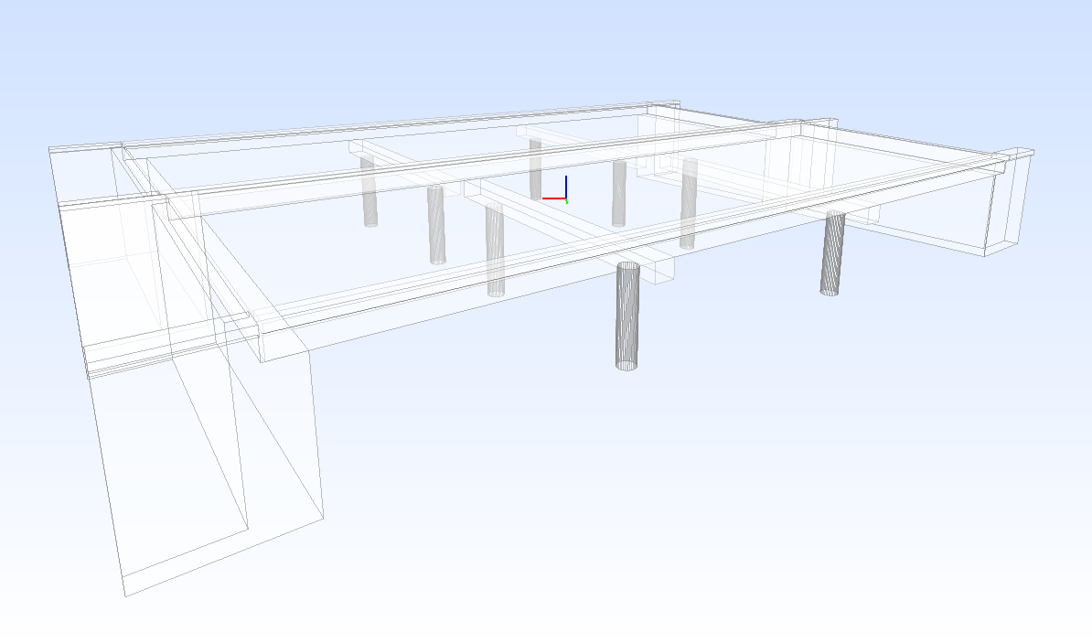

**Figure A.1 - Viaduct example**

### A.2.1 Example container - information delivery requirements

This example explains the container provided by the client.

Figure A.2 shows the structure of the container and shows the documents that are made available.

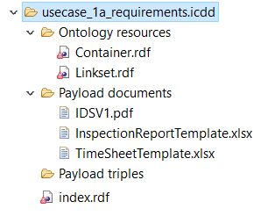

**Figure A.2 - Example of a container structure**

The Index.rdf in the root folder contains a listing of all the requested documents and docs well as those already available in the container. Figure A.3 shows an instance of a *ct:ContainerDescription*.

The instance has an URI which is highlighted in the resource form at the top of the screenshot and is treated as the unique identifier for this container. This individual has an *rdf:type* predicate set to *ct:ContainerDescription* making this resource a member of this class. As shown, this individual is described by several other predicates, each either having a prescribed value (e.g. *ct:description*) or referring to URIs that identify other objects (e.g. *ct:createdBy* refers to an instance of *ct:Party* via its URI).

In this example, the individual is related via the *ct:containsDocument* predicate to seven other URIs. One of these is opened up in Figure A.4, showing that it is of the type (*rdf:type*) *ct:InternalDocument* with properties *ct:description*, *ct:filename*, *ct:filetype*, *ct:name* and the *ct:requested* boolean, which in this case, is set to true because the spreadsheet is requested to be provided by the contractor. The other URIs can be opened as well.

Note that some documents are required to be provided by the receiver in a return container (see A2.2) flagged by setting the *ct:requested* boolean to true. Other documents are available in the container and consequently, are not requested (*ct:requested* is set to false)

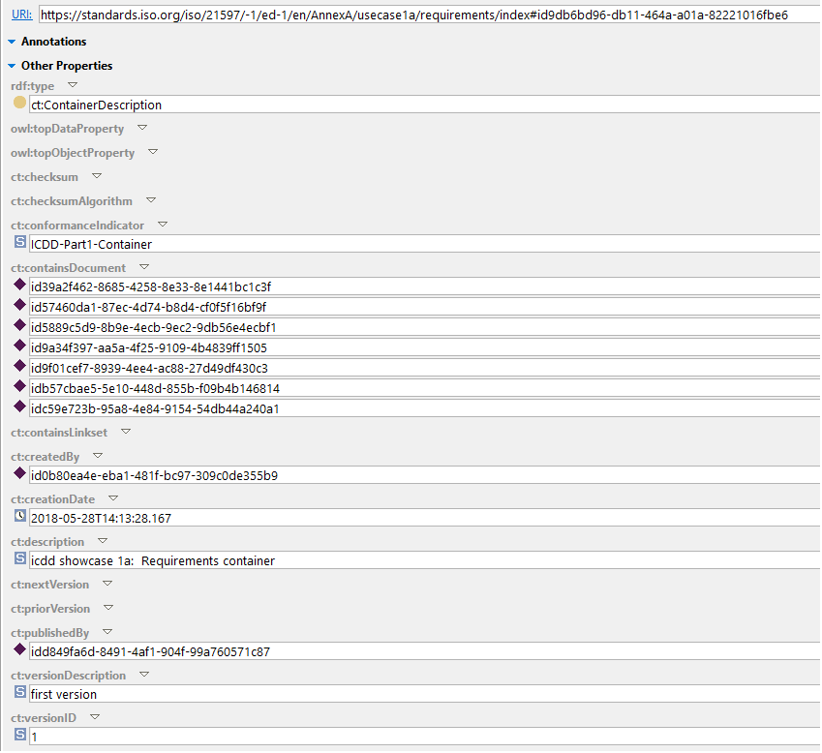

**Figure A.3 - Example of *ct:ContainerDescription* in the Index.rdf file of a container**

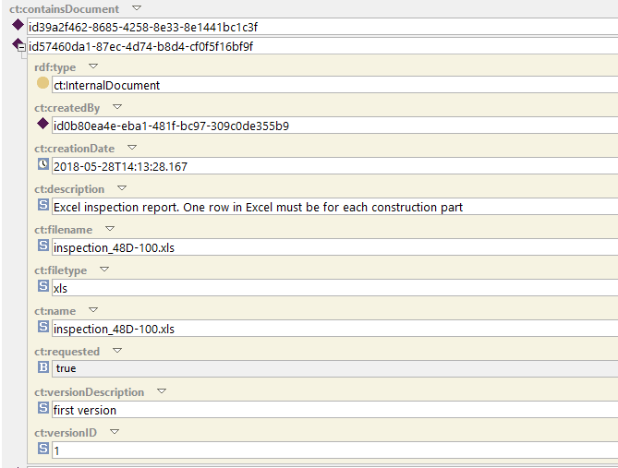

**Figure A.4 - A linked document (requested inspection report) in the example Index file**

This container can be downloaded via: <https://standards.iso.org/iso/21597/-1/ed-1/en/AnnexA/usecase1a/requirements.icdd>

### A.2.2 Example container - information delivery

This example explains the container returned by the contractor.

The delivery container contains the inspection report as a spreadsheet and the timesheet in the payload folder of the container. The payload folder also contains a 3D IFC model and some pictures supporting the inspection report. See Figure A.5 for the structure of the container.

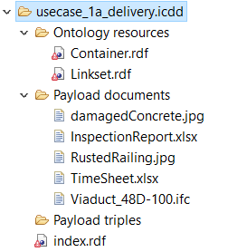

**Figure A.5 - Example of container structure**

The *ct:ContainerDescription* links to the documents via individuals of *ct:InternalDocuments*. Figure A.6 shows the container description that links to an internal document.

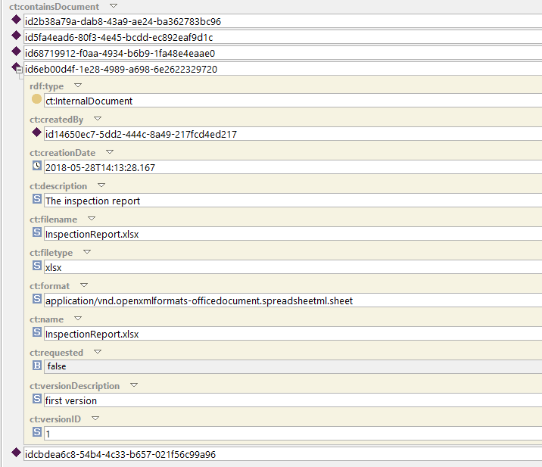

**Figure A.6 - A linked document (inspection report) in the example Index file**

This container can be downloaded via: <https://standards.iso.org/iso/21597/-1/ed-1/en/AnnexA/usecase1a/delivery.icdd>

## A.3 Use case 1B – Delivery of documents with links

This use case is an extension of use case 1A. In this use case the client asks also to provide

* The links between the construction parts as specified in the inspection report and the IFC elements
* The links between the construction parts as specified in the inspection report and photos.

For the purpose of the assignment, the client provides a container, equipped with slots for the requested documents. The above-mentioned requirements are added to the information delivery specification and is stored as a successor of the information delivery specification used in the previous use case.

The client uses containers supplied by contractors for the purpose of reviewing inspection reports. This means that the client has an application that shows the inspection report (Excel table), displays the corresponding construction parts in a 3D-model and shows available photos for every construction part.

### A.3.1 Example container - information delivery requirements

This container is very similar to the previous example and contains two information delivery specifications which are related to each other via the *ct:priorVersion* property. Figure A.7 shows the link to the new information delivery specification document.

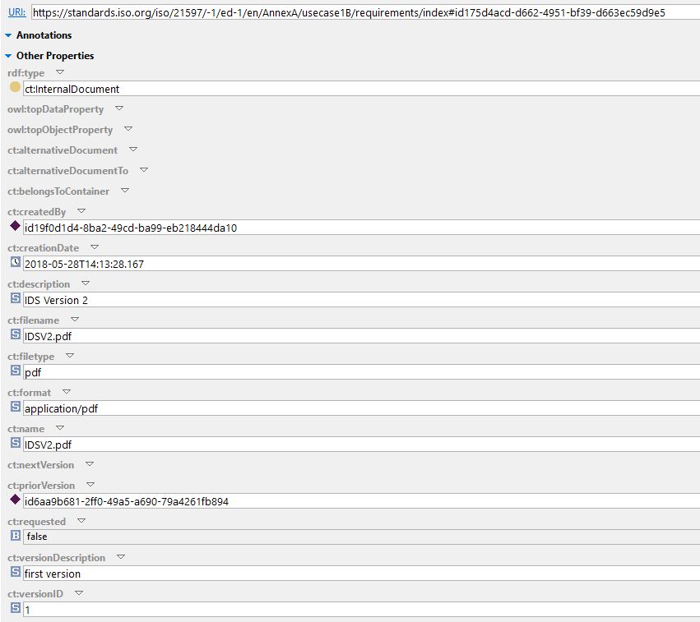

**Figure A.7 - Example of a new Internal document with a *ct:priorVersion***

In addition, this container contains three links between documents. The links are instances of *ls:Link*. Figure A.8 shows all information of one link. The URI of the *ls:Link* instance is highlighted. This instance is connected via the *ls:hasLinkElement* with 2 instances of *ls:LinkElement* via their respective URIs. Both of these URIs are opened in Figure A.8 and have an *ls:hasDocument* connection to individuals of class *ct:InternalDocument* that are defined in the Index.rdf.

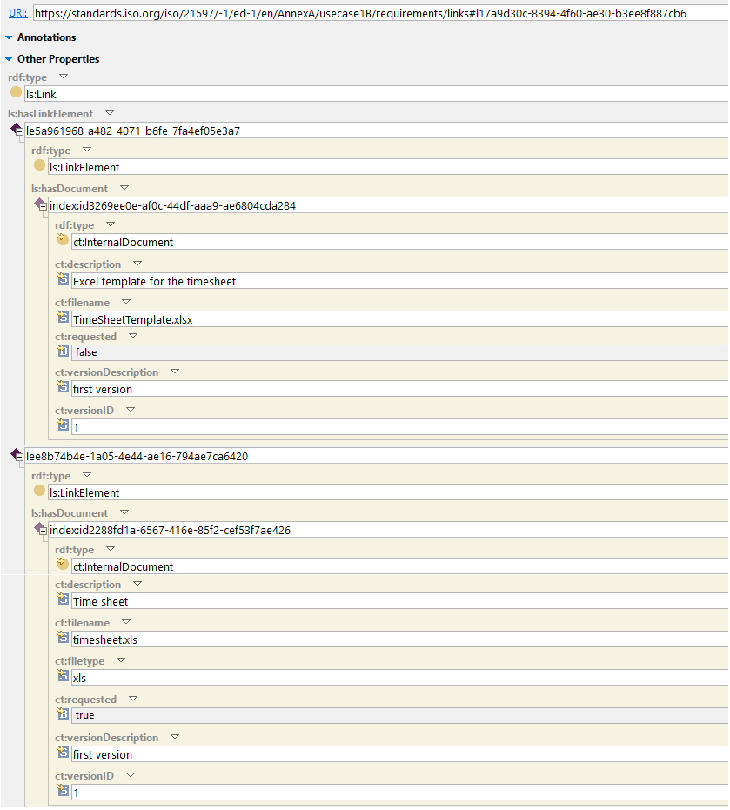

**Figure A.8 - Example of a link between a Timesheet template and the requested timesheet**

This container can be downloaded via:

<https://standards.iso.org/iso/21597/-1/ed-1/en/AnnexA/usecase1b/requirements.icdd>

### A.3.2 Example container - information delivery

This example explains the container returned by the contractor.

The contractor provides a container with the following information:

* Inspection report
* Timesheet report
* IFC model
* Photos of detected asset issues
* The links between the construction parts as specified in the Inspection report and the IFC elements
* The links between the construction parts and photos.

The container has detailed links between the IFC model and the inspection report spreadsheet. Elements in the IFC file are identified using the GUID and linked to a specific row in the inspection report. In addition, the link includes a picture. Consequently, an *ls:Link* is related to three instances of *ls:LinkElement*. Figure A.9 shows an *ls:Link* instance that has three instances of *ls:LinkElement*. One of these instances is opened, which refers via *ct:Linkset:hasDocument* to the an internal document (rustedRailing.jpg).

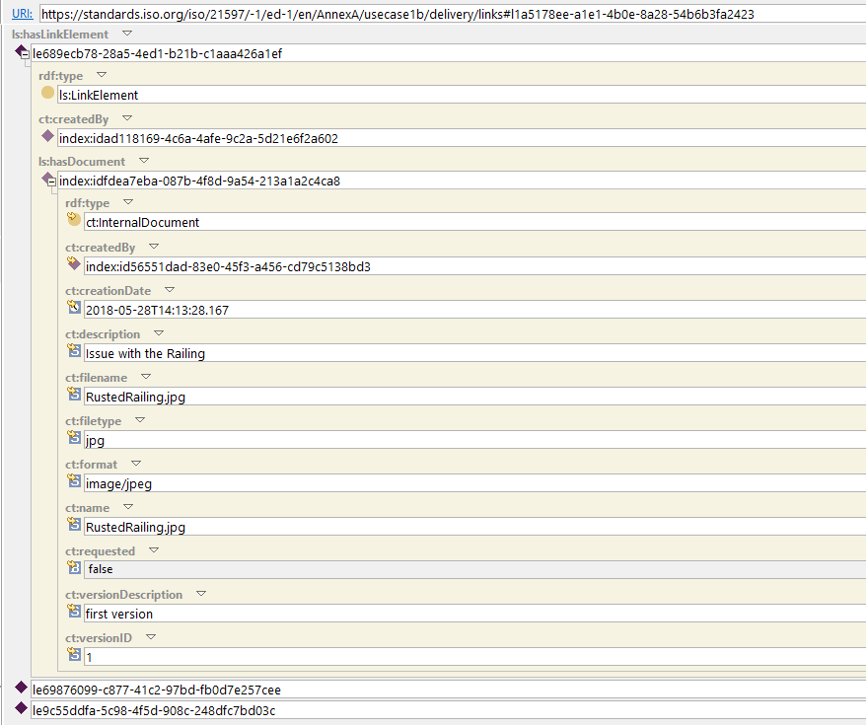

**Figure A.9 - Example of a link with an opened *ls:LinkElement* pointing to a JPG file**

The other instances of *ls:LinkElement* refer to the excel sheet and to an IFC Entity within an IFC file. Therefore an *ls:StringBasedIdentifier* is used to capture the GUID of the IFC entity. Figure A.10 shows the same *ls:Link* but this time the *ls:LinkElement* referring to the inspection report and the *ls:LinkElement* referring to the IFC file are opened. Also the *ct:Linkset:hasIdentifier* is opened demonstrating the reference to an *ls:StringBasedIdentifier*.

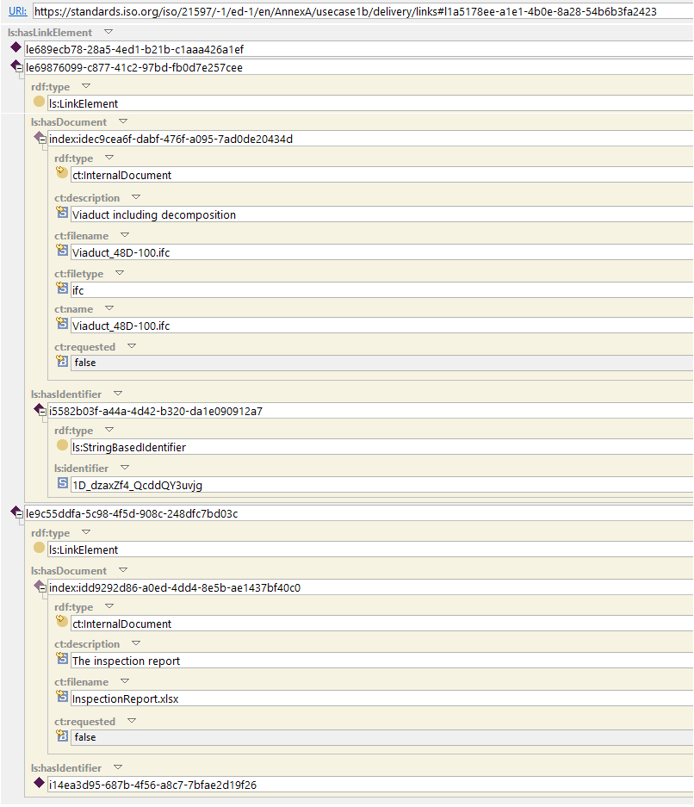

**Figure A.10 - Example of a link with 2 opened instances of *ls:LinkElement***

Figure A.11 shows a document with an additional property. The Dublin Core (see the informative annex, Annex B) “rights” predicate is used to add extra information to a document individual.

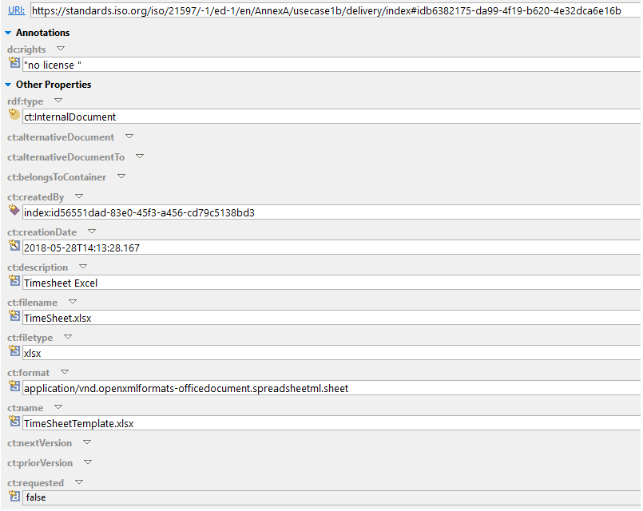

**Figure A.11 - Example of a document with an additional property dc:rights with the value “no license”.**

As all data is expressed in RDF it is possible to query the data using SPARQL. For example it is possible to retrieve links via a single SPARQL query. Figure A.12 shows a SPARQL query that searches the data for links and retrieves the identifiers and filenames of document.

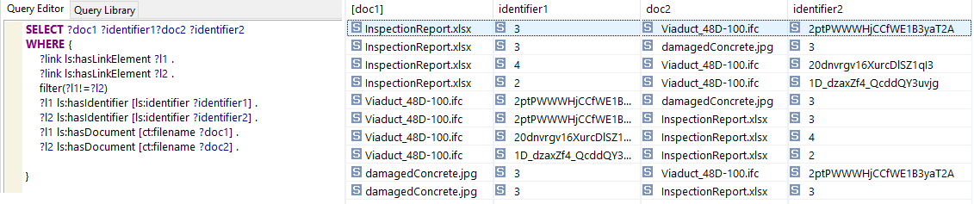

**Figure A.12 - Example of using SPARQL to retrieve the links**

This container can be downloaded via:

<https://standards.iso.org/iso/21597/-1/ed-1/en/AnnexA/usecase1b/delivery.icdd>

# Annex B (informative) Dublin Core interoperability

A container has an Index dataset and may contain one or more Link datasets. Those datasets are RDF(S)/OWL files and can be used as Linked Open Data. Consequently, ICDD properties can be linked with Dublin Core properties in order to comply with commonly understood semantics. The Dublin Core vocabulary can be found at <http://dublincore.org/specifications/dublin-core/dcmi-terms/>.

Linking can be done by using, for example, *owl:equivalentProperty* or *rdfs:subPropertyOf*.

Table B1 illustrates a list of properties that can be linked. The “dc” namespace stands for “http://purl.org/dc/elements/1.1/”

**Table B1 - Container properties that can be linked to Dublin Core**

|  |  |
| --- | --- |
| **ICDD property** | **Dublin Core property** |
| *ct:format* | *dc:format* |
| *ct:filename* | *dc:identifier* |
| *ct:publisher* | *dc:publisher* |
| *ct:description* | *dc:description* |
| *ct:url* | *dc:identifier* |

# Annex C (informative) Bidirectional conversion of the ICDD container representation from RDF(S)/OWL to XSD/XML

This part of the ISO 21597 series uses W3C RDF(S)/OWL technology to specify the ontologies that define the structure and links in a container. However, many software companies have not yet made the transition to RDF(S)/OWL. In order to make the threshold for adoption of this part of the ISO 21597 series as low as possible, specifications are included in this annex that support the conversion of a container from RDF(S)/OWL version 1.0 to XSD/XML Version 3.0 and vice versa. The conversion is fully consistent in both directions, with no information lost or changed.

Note: XML Version 1.0 and 2.0 are already applied in German DIN SPEC 91350 standards as Multimodel Container MMC Version 1.0 and 2.0 respectively.

The following files are available:

XSD files:

* Container.xsd, an XSD representation of Container.rdf; available via the following link: <https://standards.iso.org/iso/21597/-1/ed-1/en/AnnexC/xsd/Container-3.0.xsd>
* Linkset.xsd, an XSD representation of Linkset.rdf; available via the following link: <https://standards.iso.org/iso/21597/-1/ed-1/en/AnnexC/xsd/Linkset-3.0.xsd>

XSLT files:

* Container_RDF_to_XML.xslt, a XSLT file supporting the conversion from Index.rdf to an XML. available via the following link: <https://standards.iso.org/iso/21597/-1/ed-1/en/AnnexC/ConverterFiles/Container_RDF_to_XML.xslt>
* Container_XML_to_RDF.xslt, a XSLT file supporting the conversion from XML to RDF. available via the following link: <https://standards.iso.org/iso/21597/-1/ed-1/en/AnnexC/ConverterFiles/Container_XML_to_RDF.xslt>
* Links_RDF_to_XML.xslt, a XSLT file supporting the conversion from any link dataset from an RDF version to an XML version; available via the following link: <https://standards.iso.org/iso/21597/-1/ed-1/en/AnnexC/ConverterFiles/Links_RDF_to_XML.xslt>
* Links_XML_to_RDF.xslt, a XSLT file supporting the conversion from any link dataset from an XML version to an RDF version; available via the following link: <https://standards.iso.org/iso/21597/-1/ed-1/en/AnnexC/ConverterFiles/Links_XML_to_RDF.xslt>

# https://standards.iso.org/iso/21597/-1/ed-1/en/AnnexC/xsd/Container-3.0.xsd

# Annex D (informative) How to validate with SHACL

This annex provides an example of how the RDF(S)/OWL files from an ICDD Part 1 container can be validated. Two basic validation scenarios can be distinguished:

1. Schema extension validation: it is not allowed to extend the Container or the Linkset ontologies;
2. Dataset validation: validate the data to ensure that it complies with the Container and Linkset ontologies.

Both validations may be done using the SHApe Constraint Language (SHACL). For more information see <https://www.w3.org/TR/shacl/>.

## D.1 Schema extension validation

To validate that no extra schema additions are present, two validations shall be addressed:

* Detect extra classes;
* Detect extra predicates.

### D.1.1 Detecting extra classes

In this approach, all Part 1 classes are annotated to enable an easy detection query to find disallowed classes. This is done in a separate SHACL/RDF file called “Part1ClassesCheck.shapes.rdf” where all legitimate Part 1 classes are specified as members of a newly introduced (meta-)Class called ICDDClass (Figure D.1).

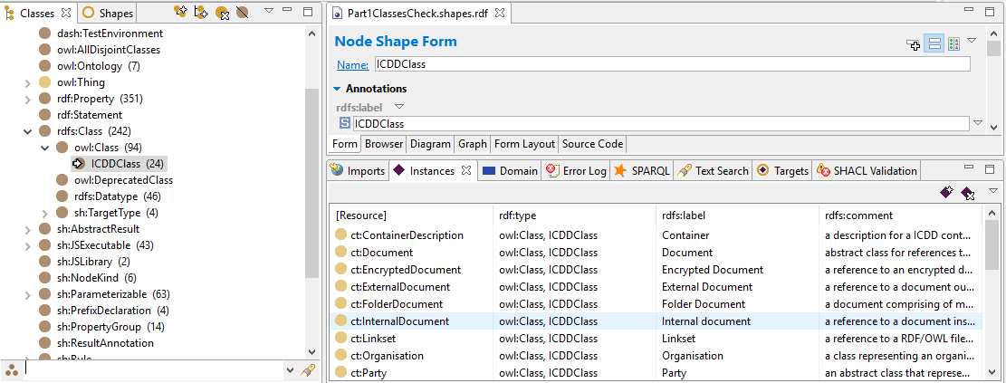

**Figure D.1 - SHACL/RDF file to detect invalid classes**

All classes used in an ICDD container should be a member of the ICDDClass. If this is not the case then a disallowed class is detected. This test can be easily encoded via a SHACL Node using a SPARQL query. Figure D.2 shows an example of a shape testing whether illegal classes are used. It uses a SPARQL query and a message stating this class extension is not allowed.

To test this shape, a class named “MyIllegalDocumentExtension” has been added as a subclass of Container:Document class. When executing the SHACL rules, the following message appears: ”[My illegal document extension] class extension is not allowed”, as shown in Figure D.2.

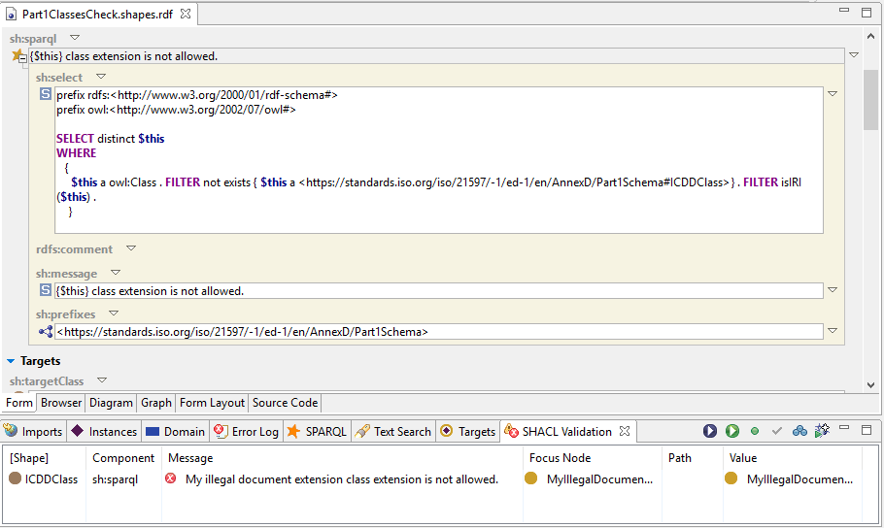

**Figure D.2 - SHACL Node Class Form to test for invalid classes**

The SHACL/RDF file used is this example can be downloaded from:

<https://standards.iso.org/iso/21597/-1/ed-1/en/AnnexD/Part1ClassesCheck.shapes.rdf>

### D.1.2 Detecting extra predicates

To detect invalid predicates within a dataset, the same approach can be adopted as explained in the previous subclause to detect extra classes. All predicates that can be used in Part1 can be annotated in a separate SHACL/RDF file. A SHACL SPARQL query could then be developed by a user to verify that all predicates used in the dataset file are Part1 predicates.

## D.2 Data validation

The example in this section illustrates how data can be checked for compliance with the Container and Linkset ontologies following a closed world assumption. SHACL has built-in mechanisms to check datatype values to ensure they match the specification. Cardinality constraints can also be described and validated.

Figure D.3 shows an index test file called “indexForValidation.rdf” importing “Container.shapes.rdf”, a SHACL variant of the Container.rdf ontology. It is shown that errors are generated when executing the SHACL code having to do with missing data where a minimum cardinality constraint was defined as “1” and also, the other way round, for a property called “*ct:wrongName*” that should not have been there in the data.

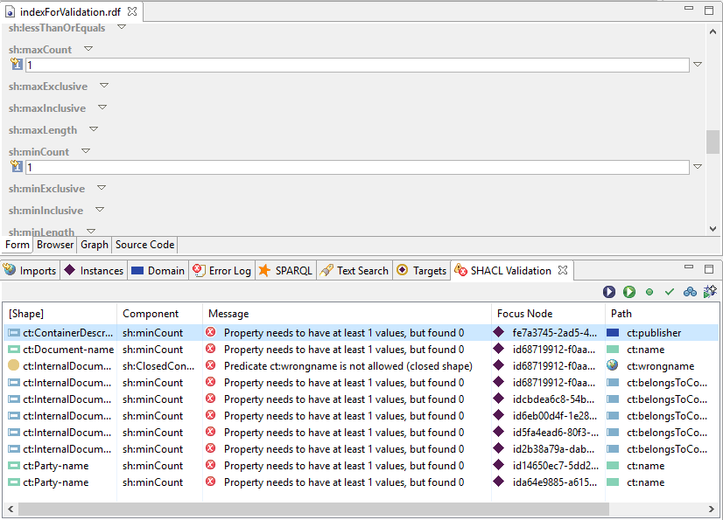

**Figure D.3 - Example of a data type and cardinality validation**

The SHACL/RDF files used is this example can be downloaded as follows:

<https://standards.iso.org/iso/21597/-1/ed-1/en/AnnexD/indexForValidation.rdf>

<https://standards.iso.org/iso/21597/-1/ed-1/en/AnnexD/Container.shapes.rdf>

# Annex E (normative) Ontologies

## E.1 Container ontology

The Container ontology can be found via <https://standards.iso.org/iso/21597/-1/ed-1/en/Container>

The full ontology is listed here, serialised in RDF/XML [W3C-RDF11-XML].

<?xml version="1.0"?>

<rdf:RDF

xmlns="https://standards.iso.org/iso/21597/-1/ed-1/en/Container#"

xmlns:rdf="http://www.w3.org/1999/02/22-rdf-syntax-ns#"

xmlns:dc="http://purl.org/dc/elements/1.1/"

xmlns:owl="http://www.w3.org/2002/07/owl#"

xmlns:rdfs="http://www.w3.org/2000/01/rdf-schema#"

xmlns:vann="http://purl.org/vocab/vann/"

xmlns:xsd="http://www.w3.org/2001/XMLSchema#"

xml:base="https://standards.iso.org/iso/21597/-1/ed-1/en/Container">

<owl:Ontology rdf:about="">

<dc:rights>This ontology is part of ISO standard ISO 21597-1:2019</dc:rights>

<owl:versionIRI rdf:resource=""/>

</owl:Ontology>

<owl:Class rdf:ID="Document">

<owl:disjointUnionOf rdf:parseType="Collection">

<owl:Class rdf:ID="ExternalDocument"/>

<owl:Class rdf:ID="InternalDocument"/>

</owl:disjointUnionOf>

<rdfs:subClassOf>

<owl:Restriction>

<owl:minCardinality rdf:datatype="http://www.w3.org/2001/XMLSchema#nonNegativeInteger"

>0</owl:minCardinality>

<owl:onProperty>

<owl:InverseFunctionalProperty rdf:ID="nextVersion"/>

</owl:onProperty>

</owl:Restriction>

</rdfs:subClassOf>

<rdfs:label xml:lang="en-GB">Document</rdfs:label>

<rdfs:comment xml:lang="en-GB">abstract class for references to a document; an individual shall at least be member of ct:ExternalDocument or ct:InternalDocument; and optionally, individuals can be a member of other subtypes of ct:Document such as ct:SecuredDocument and/or ct:EncryptedDocument</rdfs:comment>

<rdfs:subClassOf rdf:resource="http://www.w3.org/2002/07/owl#Thing"/>

<rdfs:subClassOf>

<owl:Restriction>

<owl:onProperty>

<owl:ObjectProperty rdf:ID="priorVersion"/>

</owl:onProperty>

<owl:allValuesFrom rdf:resource="#Document"/>

</owl:Restriction>

</rdfs:subClassOf>

<rdfs:subClassOf>

<owl:Restriction>

<owl:cardinality rdf:datatype="http://www.w3.org/2001/XMLSchema#nonNegativeInteger"

>1</owl:cardinality>

<owl:onProperty>

<owl:FunctionalProperty rdf:ID="name"/>

</owl:onProperty>

</owl:Restriction>

</rdfs:subClassOf>

<rdfs:subClassOf>

<owl:Restriction>

<owl:maxCardinality rdf:datatype="http://www.w3.org/2001/XMLSchema#nonNegativeInteger"

>1</owl:maxCardinality>

<owl:onProperty>

<owl:FunctionalProperty rdf:ID="requested"/>

</owl:onProperty>

</owl:Restriction>

</rdfs:subClassOf>

<rdfs:subClassOf>

<owl:Restriction>

<owl:minCardinality rdf:datatype="http://www.w3.org/2001/XMLSchema#nonNegativeInteger"

>0</owl:minCardinality>

<owl:onProperty>

<owl:ObjectProperty rdf:about="#priorVersion"/>

</owl:onProperty>

</owl:Restriction>

</rdfs:subClassOf>

<rdfs:subClassOf>

<owl:Restriction>

<owl:allValuesFrom rdf:resource="#Document"/>

<owl:onProperty>

<owl:InverseFunctionalProperty rdf:about="#nextVersion"/>

</owl:onProperty>

</owl:Restriction>

</rdfs:subClassOf>

</owl:Class>

<owl:Class rdf:about="#ExternalDocument">

<rdfs:subClassOf rdf:resource="#Document"/>

<rdfs:comment xml:lang="en-GB">a reference to a document outside a container</rdfs:comment>

<rdfs:subClassOf>

<owl:Restriction>

<owl:cardinality rdf:datatype="http://www.w3.org/2001/XMLSchema#nonNegativeInteger"

>1</owl:cardinality>

<owl:onProperty>

<owl:FunctionalProperty rdf:ID="url"/>

</owl:onProperty>

</owl:Restriction>

</rdfs:subClassOf>

<rdfs:label xml:lang="en-GB">External Document</rdfs:label>

</owl:Class>

<owl:Class rdf:ID="FolderDocument">

<rdfs:comment xml:lang="en-GB">a document comprising of multiple files located in one folder, such as a GIS dataset consisting SHP files with associated DBF files</rdfs:comment>

<rdfs:label xml:lang="en-GB">Folder Document</rdfs:label>

<rdfs:subClassOf>

<owl:Restriction>

<owl:cardinality rdf:datatype="http://www.w3.org/2001/XMLSchema#nonNegativeInteger"

>1</owl:cardinality>

<owl:onProperty>

<owl:DatatypeProperty rdf:ID="foldername"/>

</owl:onProperty>

</owl:Restriction>

</rdfs:subClassOf>

<rdfs:subClassOf rdf:resource="#Document"/>

</owl:Class>

<owl:Class rdf:ID="EncryptedDocument">

<rdfs:subClassOf rdf:resource="#Document"/>

<rdfs:comment xml:lang="en-GB">a reference to an encrypted document</rdfs:comment>

<rdfs:label xml:lang="en-GB">Encrypted Document</rdfs:label>

</owl:Class>

<owl:Class rdf:ID="Organisation">

<rdfs:subClassOf>

<owl:Class rdf:ID="Party"/>

</rdfs:subClassOf>

<rdfs:comment xml:lang="en-GB">a class representing an organisation for provenance purposes</rdfs:comment>

<rdfs:label xml:lang="en-GB">Organisation</rdfs:label>

</owl:Class>

<owl:Class rdf:about="#Party">

<rdfs:comment xml:lang="en-GB">an abstract class that represents the generalization of a ct:Organisation or a ct:Person; entities can refer to an individual of a subclass of ct:Party via the ct:creator, ct:modifier or ct:publisher object properties.</rdfs:comment>

<rdfs:subClassOf rdf:resource="http://www.w3.org/2002/07/owl#Thing"/>

<rdfs:subClassOf>

<owl:Restriction>

<owl:cardinality rdf:datatype="http://www.w3.org/2001/XMLSchema#nonNegativeInteger"

>1</owl:cardinality>

<owl:onProperty>

<owl:FunctionalProperty rdf:about="#name"/>

</owl:onProperty>

</owl:Restriction>

</rdfs:subClassOf>

<owl:disjointUnionOf rdf:parseType="Collection">

<owl:Class rdf:about="#Organisation"/>

<owl:Class rdf:ID="Person"/>

</owl:disjointUnionOf>

<rdfs:label xml:lang="en-GB">Party</rdfs:label>

</owl:Class>

<owl:Class rdf:ID="ContainerDescription">

<rdfs:label xml:lang="en-GB">Container</rdfs:label>

<rdfs:subClassOf>

<owl:Restriction>

<owl:cardinality rdf:datatype="http://www.w3.org/2001/XMLSchema#nonNegativeInteger"

>1</owl:cardinality>

<owl:onProperty>

<owl:DatatypeProperty rdf:ID="conformanceIndicator"/>

</owl:onProperty>

</owl:Restriction>

</rdfs:subClassOf>

<rdfs:subClassOf>

<owl:Restriction>

<owl:onProperty>

<owl:ObjectProperty rdf:about="#priorVersion"/>

</owl:onProperty>

<owl:allValuesFrom rdf:resource="#ContainerDescription"/>

</owl:Restriction>

</rdfs:subClassOf>

<rdfs:subClassOf>

<owl:Restriction>

<owl:minCardinality rdf:datatype="http://www.w3.org/2001/XMLSchema#nonNegativeInteger"

>0</owl:minCardinality>

<owl:onProperty>

<owl:ObjectProperty rdf:about="#priorVersion"/>

</owl:onProperty>

</owl:Restriction>

</rdfs:subClassOf>

<rdfs:subClassOf>

<owl:Restriction>

<owl:cardinality rdf:datatype="http://www.w3.org/2001/XMLSchema#nonNegativeInteger"

>1</owl:cardinality>

<owl:onProperty>

<owl:FunctionalProperty rdf:ID="publishedBy"/>

</owl:onProperty>

</owl:Restriction>

</rdfs:subClassOf>

<rdfs:subClassOf>

<owl:Restriction>

<owl:minCardinality rdf:datatype="http://www.w3.org/2001/XMLSchema#nonNegativeInteger"

>0</owl:minCardinality>

<owl:onProperty>

<owl:FunctionalProperty rdf:ID="createdBy"/>

</owl:onProperty>

</owl:Restriction>

</rdfs:subClassOf>

<rdfs:subClassOf>

<owl:Restriction>

<owl:maxCardinality rdf:datatype="http://www.w3.org/2001/XMLSchema#nonNegativeInteger"

>1</owl:maxCardinality>

<owl:onProperty>

<owl:FunctionalProperty rdf:ID="description"/>

</owl:onProperty>

</owl:Restriction>

</rdfs:subClassOf>

<rdfs:subClassOf>

<owl:Restriction>

<owl:allValuesFrom rdf:resource="#Document"/>

<owl:onProperty>

<owl:ObjectProperty rdf:ID="containsDocument"/>

</owl:onProperty>

</owl:Restriction>

</rdfs:subClassOf>

<rdfs:subClassOf>

<owl:Restriction>

<owl:allValuesFrom rdf:resource="#ContainerDescription"/>

<owl:onProperty>

<owl:InverseFunctionalProperty rdf:about="#nextVersion"/>

</owl:onProperty>

</owl:Restriction>

</rdfs:subClassOf>

<rdfs:comment xml:lang="en-GB">a description for a ICDD container where all documents are listed and where Link datasets can be found</rdfs:comment>

<rdfs:subClassOf>

<owl:Restriction>

<owl:allValuesFrom>

<owl:Class rdf:ID="Linkset"/>

</owl:allValuesFrom>

<owl:onProperty>

<owl:ObjectProperty rdf:ID="containsLinkset"/>

</owl:onProperty>

</owl:Restriction>

</rdfs:subClassOf>

</owl:Class>

<owl:Class rdf:about="#InternalDocument">

<rdfs:subClassOf>

<owl:Restriction>

<owl:allValuesFrom rdf:resource="http://www.w3.org/2001/XMLSchema#string"/>

<owl:onProperty>

<owl:FunctionalProperty rdf:ID="filename"/>

</owl:onProperty>

</owl:Restriction>

</rdfs:subClassOf>

<rdfs:subClassOf>

<owl:Restriction>

<owl:cardinality rdf:datatype="http://www.w3.org/2001/XMLSchema#nonNegativeInteger"

>1</owl:cardinality>

<owl:onProperty>

<owl:FunctionalProperty rdf:about="#filename"/>

</owl:onProperty>

</owl:Restriction>

</rdfs:subClassOf>

<rdfs:subClassOf>

<owl:Restriction>

<owl:cardinality rdf:datatype="http://www.w3.org/2001/XMLSchema#nonNegativeInteger"

>1</owl:cardinality>

<owl:onProperty>

<owl:DatatypeProperty rdf:ID="filetype"/>

</owl:onProperty>

</owl:Restriction>

</rdfs:subClassOf>

<rdfs:subClassOf>

<owl:Restriction>

<owl:cardinality rdf:datatype="http://www.w3.org/2001/XMLSchema#nonNegativeInteger"

>1</owl:cardinality>

<owl:onProperty>

<owl:ObjectProperty rdf:ID="belongsToContainer"/>

</owl:onProperty>

</owl:Restriction>

</rdfs:subClassOf>

<rdfs:label xml:lang="en-GB">Internal document</rdfs:label>

<rdfs:comment xml:lang="en-GB">a reference to a document inside a container</rdfs:comment>

<rdfs:subClassOf rdf:resource="#Document"/>

</owl:Class>

<owl:Class rdf:about="#Person">

<rdfs:subClassOf rdf:resource="#Party"/>

<rdfs:label xml:lang="en-GB">Person</rdfs:label>

<rdfs:comment xml:lang="en-GB">a class representing an person for provenance purposes</rdfs:comment>

</owl:Class>

<owl:Class rdf:about="#Linkset">

<rdfs:subClassOf>

<owl:Restriction>

<owl:onProperty>

<owl:InverseFunctionalProperty rdf:about="#nextVersion"/>

</owl:onProperty>

<owl:allValuesFrom rdf:resource="#Linkset"/>

</owl:Restriction>

</rdfs:subClassOf>

<rdfs:comment xml:lang="en-GB">a reference to a RDF/OWL file containing links</rdfs:comment>

<rdfs:subClassOf>

<owl:Restriction>

<owl:onProperty>

<owl:ObjectProperty rdf:about="#priorVersion"/>

</owl:onProperty>

<owl:allValuesFrom rdf:resource="#Linkset"/>

</owl:Restriction>

</rdfs:subClassOf>

<rdfs:label xml:lang="en-GB">Linkset</rdfs:label>

<rdfs:subClassOf>

<owl:Restriction>

<owl:minCardinality rdf:datatype="http://www.w3.org/2001/XMLSchema#nonNegativeInteger"

>0</owl:minCardinality>

<owl:onProperty>

<owl:ObjectProperty rdf:about="#priorVersion"/>

</owl:onProperty>

</owl:Restriction>

</rdfs:subClassOf>

<rdfs:subClassOf>

<owl:Restriction>

<owl:cardinality rdf:datatype="http://www.w3.org/2001/XMLSchema#nonNegativeInteger"

>1</owl:cardinality>

<owl:onProperty>

<owl:FunctionalProperty rdf:about="#filename"/>

</owl:onProperty>

</owl:Restriction>

</rdfs:subClassOf>

</owl:Class>

<owl:Class rdf:ID="SecuredDocument">

<rdfs:subClassOf rdf:resource="#Document"/>

<rdfs:subClassOf>

<owl:Restriction>

<owl:cardinality rdf:datatype="http://www.w3.org/2001/XMLSchema#nonNegativeInteger"

>1</owl:cardinality>

<owl:onProperty>

<owl:FunctionalProperty rdf:ID="checksum"/>

</owl:onProperty>

</owl:Restriction>

</rdfs:subClassOf>

<rdfs:subClassOf>

<owl:Restriction>

<owl:cardinality rdf:datatype="http://www.w3.org/2001/XMLSchema#nonNegativeInteger"

>1</owl:cardinality>

<owl:onProperty>

<owl:FunctionalProperty rdf:ID="checksumAlgorithm"/>

</owl:onProperty>

</owl:Restriction>

</rdfs:subClassOf>

<rdfs:label xml:lang="en-GB">Secured document</rdfs:label>

<rdfs:comment xml:lang="en-GB">a document secured by a checksum algorithm (see also properties ct:checksum and ct:checksumAlgorithm )</rdfs:comment>

</owl:Class>

<owl:ObjectProperty rdf:about="#containsLinkset">

<rdfs:range rdf:resource="#Linkset"/>

<rdfs:label xml:lang="en-GB">contains linkset</rdfs:label>

<rdfs:comment xml:lang="en-GB">a relation from a ct:ContainerDescription to a ct:Linkset reference. Multiple linkset references are allowed.</rdfs:comment>

<rdfs:domain rdf:resource="#ContainerDescription"/>

</owl:ObjectProperty>

<owl:ObjectProperty rdf:about="#belongsToContainer">

<owl:inverseOf>

<owl:ObjectProperty rdf:about="#containsDocument"/>

</owl:inverseOf>

<rdfs:comment xml:lang="en-GB">a owl property defining the relation between a document reference and a container</rdfs:comment>

<rdfs:range rdf:resource="#ContainerDescription"/>

<rdfs:label xml:lang="en-GB">belongs to container</rdfs:label>

<rdfs:domain rdf:resource="#Document"/>

</owl:ObjectProperty>

<owl:ObjectProperty rdf:ID="created">

<rdfs:label xml:lang="en-GB">created</rdfs:label>

<rdfs:comment xml:lang="en-GB">a reference to an instance that was created by this Party</rdfs:comment>

<owl:inverseOf>

<owl:FunctionalProperty rdf:about="#createdBy"/>

</owl:inverseOf>

<rdfs:domain rdf:resource="#Party"/>

</owl:ObjectProperty>

<owl:ObjectProperty rdf:about="#containsDocument">

<rdfs:domain rdf:resource="#ContainerDescription"/>

<rdfs:range rdf:resource="#Document"/>

<rdfs:comment xml:lang="en-GB">a relation from ct:ContainerDescription to a document reference. Relations to multiple document references is allowed</rdfs:comment>

<rdfs:label xml:lang="en-GB">contains model</rdfs:label>

<owl:inverseOf rdf:resource="#belongsToContainer"/>

</owl:ObjectProperty>

<owl:ObjectProperty rdf:ID="published">

<rdfs:label xml:lang="en-GB">published</rdfs:label>

<rdfs:comment xml:lang="en-GB">a reference to a container published by a Party</rdfs:comment>

<rdfs:domain rdf:resource="#Party"/>

<owl:inverseOf>

<owl:FunctionalProperty rdf:about="#publishedBy"/>

</owl:inverseOf>

</owl:ObjectProperty>

<owl:ObjectProperty rdf:ID="alternativeDocument">

<rdfs:domain rdf:resource="#Document"/>

<rdfs:label xml:lang="en-GB">alternative document</rdfs:label>

<rdfs:comment xml:lang="en-GB">a property to link a document to an alternative version of that document</rdfs:comment>

<rdfs:range rdf:resource="#Document"/>

</owl:ObjectProperty>

<owl:ObjectProperty rdf:ID="alternativeDocumentTo">

<rdfs:range rdf:resource="#Document"/>

<rdfs:label xml:lang="en-GB">alternative document to</rdfs:label>

<rdfs:comment xml:lang="en-GB">a property to link a document to the main version of that document</rdfs:comment>

<rdfs:domain rdf:resource="#Document"/>

<owl:inverseOf rdf:resource="#alternativeDocument"/>

</owl:ObjectProperty>

<owl:ObjectProperty rdf:about="#priorVersion">

<rdfs:comment xml:lang="en-GB">an optional reference to the prior version of this resource</rdfs:comment>

<rdfs:label xml:lang="en-GB">prior version</rdfs:label>

<rdf:type rdf:resource="http://www.w3.org/2002/07/owl#FunctionalProperty"/>

</owl:ObjectProperty>

<owl:ObjectProperty rdf:ID="modified">

<rdfs:domain rdf:resource="#Party"/>

<rdfs:comment xml:lang="en-GB">a reference to an instance that was modified by this Party</rdfs:comment>

<rdfs:label xml:lang="en-GB">modified</rdfs:label>

<owl:inverseOf>

<owl:FunctionalProperty rdf:ID="modifiedBy"/>

</owl:inverseOf>

</owl:ObjectProperty>

<owl:DatatypeProperty rdf:about="#filetype">

<rdfs:range rdf:resource="http://www.w3.org/2001/XMLSchema#string"/>

<rdfs:label xml:lang="en-GB">filetype</rdfs:label>

<rdfs:comment xml:lang="en-GB">a string that specifies the file type such as "GML", "IFC", "shp", "xlsx", "pdf","rvt"; the string may be a compound string in indicating also version and data format (e.g. "ifc-4-xml-zip")</rdfs:comment>

<rdfs:domain rdf:resource="#Document"/>

<rdf:type rdf:resource="http://www.w3.org/2002/07/owl#FunctionalProperty"/>

</owl:DatatypeProperty>

<owl:DatatypeProperty rdf:ID="encryptionAlgorithm">

<rdfs:label>encryption algorithm</rdfs:label>

<rdfs:range rdf:resource="http://www.w3.org/2001/XMLSchema#string"/>

<rdfs:comment xml:lang="en-GB">optional string describing the encryption</rdfs:comment>

<rdfs:domain rdf:resource="#EncryptedDocument"/>

<rdf:type rdf:resource="http://www.w3.org/2002/07/owl#FunctionalProperty"/>

</owl:DatatypeProperty>

<owl:DatatypeProperty rdf:about="#conformanceIndicator">

<rdfs:comment xml:lang="en-GB">a string based indicator for ct:ContainerDescription to show to which part of the Standar this container conforms: for a Part 1 container, the value should be set to "ICDD-Part1-Container"; the range is not restricted to allow other indicator values</rdfs:comment>

<rdfs:range rdf:resource="http://www.w3.org/2001/XMLSchema#string"/>

<rdfs:label xml:lang="en-GB">conformance indicator</rdfs:label>

<rdf:type rdf:resource="http://www.w3.org/2002/07/owl#FunctionalProperty"/>

</owl:DatatypeProperty>

<owl:DatatypeProperty rdf:about="#foldername">

<rdfs:domain rdf:resource="#FolderDocument"/>

<rdfs:comment xml:lang="en-GB">a folder name for specifying a folder where a multi file document can be found; the root corresponds with the payload-documents folder of the ICDD container; the forward slash character ("/") shall be used as a folder separator.&#xD;

NOTE: An example of a foldername is “GIS Datasets/Terrain” which refers to the folder Terrain inside folder GIS Datasets inside the Payload documents folder in the container.</rdfs:comment>

<rdfs:label xml:lang="en-GB">foldername</rdfs:label>

<rdfs:range rdf:resource="http://www.w3.org/2001/XMLSchema#string"/>

<rdf:type rdf:resource="http://www.w3.org/2002/07/owl#FunctionalProperty"/>

</owl:DatatypeProperty>

<owl:FunctionalProperty rdf:about="#checksumAlgorithm">

<rdfs:domain>

<owl:Class>

<owl:unionOf rdf:parseType="Collection">

<owl:Class rdf:about="#SecuredDocument"/>

<owl:Class rdf:about="#ContainerDescription"/>

</owl:unionOf>

</owl:Class>

</rdfs:domain>

<rdfs:comment xml:lang="en-GB">the algorithm used to generate the checksum hash</rdfs:comment>

<rdfs:range rdf:resource="http://www.w3.org/2001/XMLSchema#string"/>

<rdfs:label xml:lang="en-GB">checksum algorithm</rdfs:label>

<rdf:type rdf:resource="http://www.w3.org/2002/07/owl#DatatypeProperty"/>

</owl:FunctionalProperty>

<owl:FunctionalProperty rdf:about="#modifiedBy">

<rdfs:range rdf:resource="#Party"/>

<rdfs:label xml:lang="en-GB">modified by</rdfs:label>

<rdfs:comment xml:lang="en-GB">a reference to a modifier of this instance which can only be a ct:Party (or a subclass of ct:Party)</rdfs:comment>

<rdf:type rdf:resource="http://www.w3.org/2002/07/owl#ObjectProperty"/>

</owl:FunctionalProperty>

<owl:FunctionalProperty rdf:ID="userID">

<rdfs:label xml:lang="en-GB">user ID</rdfs:label>

<rdfs:range rdf:resource="http://www.w3.org/2001/XMLSchema#string"/>

<rdfs:comment xml:lang="en-GB">The user defined ID</rdfs:comment>

<rdf:type rdf:resource="http://www.w3.org/2002/07/owl#DatatypeProperty"/>

</owl:FunctionalProperty>

<owl:FunctionalProperty rdf:about="#description">

<rdfs:comment xml:lang="en-GB">a general description</rdfs:comment>

<rdfs:range rdf:resource="http://www.w3.org/2001/XMLSchema#string"/>

<rdfs:label xml:lang="en-GB">description</rdfs:label>

<rdf:type rdf:resource="http://www.w3.org/2002/07/owl#DatatypeProperty"/>

</owl:FunctionalProperty>

<owl:FunctionalProperty rdf:ID="versionDescription">

<rdfs:comment xml:lang="en-GB">an optional character string that may be used to provide a description for a version of the corresponding resource</rdfs:comment>

<rdfs:range rdf:resource="http://www.w3.org/2001/XMLSchema#string"/>

<rdfs:label xml:lang="en-GB">version info</rdfs:label>

<rdf:type rdf:resource="http://www.w3.org/2002/07/owl#DatatypeProperty"/>

</owl:FunctionalProperty>

<owl:FunctionalProperty rdf:about="#name">

<rdfs:comment xml:lang="en-GB">a name for a resource</rdfs:comment>

<rdfs:label xml:lang="en-GB">name</rdfs:label>

<rdfs:range rdf:resource="http://www.w3.org/2001/XMLSchema#string"/>

<rdf:type rdf:resource="http://www.w3.org/2002/07/owl#DatatypeProperty"/>

</owl:FunctionalProperty>

<owl:FunctionalProperty rdf:about="#publishedBy">

<rdfs:range rdf:resource="#Party"/>

<rdfs:comment xml:lang="en-GB">a reference to the party responsible for making the container available</rdfs:comment>

<rdfs:label xml:lang="en-GB">published by</rdfs:label>

<rdf:type rdf:resource="http://www.w3.org/2002/07/owl#ObjectProperty"/>

</owl:FunctionalProperty>

<owl:FunctionalProperty rdf:about="#filename">

<rdfs:comment xml:lang="en-GB">the file name of a ct:Linkset or ct:InternalDocument; the root corresponds with the payload-documents folder of the ICDD container; the forward slash character ("/") shall be used as a folder separator.&#xD;

NOTE: An example of a filename is “IFC Models/MyFile_1.ifc” which refers to the file MyFile_1.ifc inside the folder IFC Models inside the Payload documents folder in the container.</rdfs:comment>

<rdfs:range rdf:resource="http://www.w3.org/2001/XMLSchema#string"/>

<rdfs:label xml:lang="en-GB">filename</rdfs:label>

<rdfs:domain>

<owl:Class>

<owl:unionOf rdf:parseType="Collection">

<owl:Class rdf:about="#Linkset"/>

<owl:Class rdf:about="#InternalDocument"/>

</owl:unionOf>

</owl:Class>

</rdfs:domain>

<rdf:type rdf:resource="http://www.w3.org/2002/07/owl#DatatypeProperty"/>

</owl:FunctionalProperty>

<owl:FunctionalProperty rdf:ID="creationDate">

<rdfs:label xml:lang="en-GB">creation date</rdfs:label>

<rdfs:range rdf:resource="http://www.w3.org/2001/XMLSchema#dateTime"/>

<rdfs:comment xml:lang="en-GB">The creation date as xsd:dateTime</rdfs:comment>

<rdf:type rdf:resource="http://www.w3.org/2002/07/owl#DatatypeProperty"/>

</owl:FunctionalProperty>

<owl:FunctionalProperty rdf:ID="versionID">

<rdfs:comment xml:lang="en-GB">an optional character string that may be used to identify a version of the corresponding resource</rdfs:comment>

<rdfs:range rdf:resource="http://www.w3.org/2001/XMLSchema#string"/>

<rdfs:label xml:lang="en-GB">version ID</rdfs:label>

<rdf:type rdf:resource="http://www.w3.org/2002/07/owl#DatatypeProperty"/>

</owl:FunctionalProperty>

<owl:FunctionalProperty rdf:ID="format">

<rdfs:comment xml:lang="en-GB">The mediatype of a document following the Internet Assigned Numbers Authority‘s specification (https://www.iana.org/assignments/media-types/media-types.xhtml);examples are 'application/pdf' and 'audio/mpeg'</rdfs:comment>

<rdfs:range rdf:resource="http://www.w3.org/2001/XMLSchema#string"/>

<rdfs:label xml:lang="en-GB">format (mediatype)</rdfs:label>

<rdfs:domain rdf:resource="#Document"/>

<rdf:type rdf:resource="http://www.w3.org/2002/07/owl#DatatypeProperty"/>

</owl:FunctionalProperty>

<owl:FunctionalProperty rdf:about="#url">

<rdfs:label xml:lang="en-GB">document URI</rdfs:label>

<rdfs:range rdf:resource="http://www.w3.org/2001/XMLSchema#anyURI"/>

<rdfs:comment xml:lang="en-GB">the URL where the exterrnal document can be found</rdfs:comment>

<rdfs:domain rdf:resource="#ExternalDocument"/>

<rdf:type rdf:resource="http://www.w3.org/2002/07/owl#DatatypeProperty"/>

</owl:FunctionalProperty>

<owl:FunctionalProperty rdf:about="#checksum">

<rdfs:comment xml:lang="en-GB">a checksum hash for the document reference; the checksum algorithm is specified by the property checksumAlgorithm</rdfs:comment>

<rdfs:domain>

<owl:Class>

<owl:unionOf rdf:parseType="Collection">

<owl:Class rdf:about="#SecuredDocument"/>

<owl:Class rdf:about="#ContainerDescription"/>

</owl:unionOf>

</owl:Class>

</rdfs:domain>

<rdfs:range rdf:resource="http://www.w3.org/2001/XMLSchema#string"/>

<rdfs:label xml:lang="en-GB">checksum</rdfs:label>

<rdf:type rdf:resource="http://www.w3.org/2002/07/owl#DatatypeProperty"/>

</owl:FunctionalProperty>

<owl:FunctionalProperty rdf:ID="modificationDate">

<rdfs:comment xml:lang="en-GB">The modification date as xsd:dateTime</rdfs:comment>

<rdfs:label xml:lang="en-GB">modification date</rdfs:label>

<rdfs:range rdf:resource="http://www.w3.org/2001/XMLSchema#dateTime"/>

<rdf:type rdf:resource="http://www.w3.org/2002/07/owl#DatatypeProperty"/>

</owl:FunctionalProperty>

<owl:FunctionalProperty rdf:about="#createdBy">

<rdfs:comment xml:lang="en-GB">a reference to a creator of this instance which can only be a ct:Party (or a subclass of ct:Party)</rdfs:comment>

<rdfs:label xml:lang="en-GB">created by</rdfs:label>

<rdfs:range rdf:resource="#Party"/>

<rdf:type rdf:resource="http://www.w3.org/2002/07/owl#ObjectProperty"/>

</owl:FunctionalProperty>

<owl:FunctionalProperty rdf:about="#requested">

<rdfs:domain rdf:resource="#Document"/>

<rdfs:range rdf:resource="http://www.w3.org/2001/XMLSchema#boolean"/>

<rdfs:label xml:lang="en-GB">pending</rdfs:label>

<rdfs:comment xml:lang="en-GB">a boolean to indicate whether a document is required or not. When this property is not set the value can be interpreted as 'false'</rdfs:comment>

<rdf:type rdf:resource="http://www.w3.org/2002/07/owl#DatatypeProperty"/>

</owl:FunctionalProperty>

<owl:InverseFunctionalProperty rdf:about="#nextVersion">

<owl:inverseOf rdf:resource="#priorVersion"/>

<rdfs:label xml:lang="en-GB">next version</rdfs:label>

<rdfs:comment xml:lang="en-GB">an optional reference to the next version of this resource</rdfs:comment>

</owl:InverseFunctionalProperty>

<owl:InverseFunctionalProperty rdf:ID="containedInContainer">

<rdfs:range rdf:resource="#ContainerDescription"/>

<rdfs:domain rdf:resource="#Linkset"/>

<rdfs:comment xml:lang="en-GB">a relation from Linkset to the ContainerDescription to which it belongs.</rdfs:comment>

<rdfs:label xml:lang="en-GB">contained by container</rdfs:label>

<owl:inverseOf rdf:resource="#containsLinkset"/>

</owl:InverseFunctionalProperty>

</rdf:RDF>

## E.2 Linkset ontology

The Linkset ontology can be found via [https://standards.iso.org/iso/21597/-1/ed-1/en/Linkset](https://standards.iso.org/iso/21597/-1/ed-1/en/Container)

The full ontology is listed here, serialised in RDF/XML [W3C-RDF11-XML].

<?xml version="1.0"?>

<rdf:RDF

xmlns:ct="https://standards.iso.org/iso/21597/-1/ed-1/en/Container#"

xmlns:rdf="http://www.w3.org/1999/02/22-rdf-syntax-ns#"

xmlns:dc="http://purl.org/dc/elements/1.1/"

xmlns:owl="http://www.w3.org/2002/07/owl#"

xmlns="https://standards.iso.org/iso/21597/-1/ed-1/en/Linkset#"

xmlns:rdfs="http://www.w3.org/2000/01/rdf-schema#"

xmlns:xsd="http://www.w3.org/2001/XMLSchema#"

xml:base="https://standards.iso.org/iso/21597/-1/ed-1/en/Linkset">

<owl:Ontology rdf:about="">

<dc:rights>This ontology is part of ISO standard ISO 21597-1:2019</dc:rights>

<owl:imports rdf:resource="https://standards.iso.org/iso/21597/-1/ed-1/en/Container"/>

</owl:Ontology>

<owl:Class rdf:ID="QueryBasedIdentifier">

<rdfs:subClassOf>

<owl:Restriction>

<owl:cardinality rdf:datatype="http://www.w3.org/2001/XMLSchema#nonNegativeInteger"

>1</owl:cardinality>

<owl:onProperty>

<owl:FunctionalProperty rdf:ID="queryExpression"/>

</owl:onProperty>

</owl:Restriction>

</rdfs:subClassOf>

<rdfs:subClassOf>

<owl:Restriction>

<owl:cardinality rdf:datatype="http://www.w3.org/2001/XMLSchema#nonNegativeInteger"

>1</owl:cardinality>

<owl:onProperty>

<owl:FunctionalProperty rdf:ID="queryLanguage"/>

</owl:onProperty>

</owl:Restriction>

</rdfs:subClassOf>

<rdfs:label xml:lang="en-GB">Query based identifier</rdfs:label>

<rdfs:subClassOf>

<owl:Class rdf:ID="Identifier"/>

</rdfs:subClassOf>

<rdfs:comment xml:lang="en-GB">the query resulting in an identifier</rdfs:comment>

</owl:Class>

<owl:Class rdf:ID="DirectedLink">

<rdfs:comment xml:lang="en-GB">An ls:Link that uses the subproperties ls:hasFromLinkElement and ls:hasToLinkElement to denote a direction of this link</rdfs:comment>

<rdfs:subClassOf>

<owl:Restriction>

<owl:minCardinality rdf:datatype="http://www.w3.org/2001/XMLSchema#nonNegativeInteger"

>1</owl:minCardinality>

<owl:onProperty>

<owl:ObjectProperty rdf:ID="hasToLinkElement"/>

</owl:onProperty>

</owl:Restriction>

</rdfs:subClassOf>

<rdfs:label xml:lang="en-GB">Directed link</rdfs:label>

<rdfs:subClassOf>

<owl:Restriction>

<owl:minCardinality rdf:datatype="http://www.w3.org/2001/XMLSchema#nonNegativeInteger"

>1</owl:minCardinality>

<owl:onProperty>

<owl:ObjectProperty rdf:ID="hasFromLinkElement"/>

</owl:onProperty>

</owl:Restriction>

</rdfs:subClassOf>

<rdfs:subClassOf>

<owl:Class rdf:ID="Link"/>

</rdfs:subClassOf>

</owl:Class>

<owl:Class rdf:ID="LinkElement">

<rdfs:subClassOf>

<owl:Restriction>

<owl:onProperty>

<owl:ObjectProperty rdf:ID="hasDocument"/>

</owl:onProperty>

<owl:qualifiedCardinality rdf:datatype="http://www.w3.org/2001/XMLSchema#nonNegativeInteger"

>1</owl:qualifiedCardinality>

<owl:onClass rdf:resource="https://standards.iso.org/iso/21597/-1/ed-1/en/Container#Document"/>

</owl:Restriction>

</rdfs:subClassOf>

<rdfs:subClassOf>

<owl:Restriction>

<owl:onClass>

<owl:Class rdf:about="#Identifier"/>

</owl:onClass>

<owl:maxQualifiedCardinality rdf:datatype="http://www.w3.org/2001/XMLSchema#nonNegativeInteger"

>1</owl:maxQualifiedCardinality>

<owl:onProperty>

<owl:ObjectProperty rdf:ID="hasIdentifier"/>

</owl:onProperty>

</owl:Restriction>

</rdfs:subClassOf>

<rdfs:subClassOf rdf:resource="http://www.w3.org/2002/07/owl#Thing"/>

<rdfs:label xml:lang="en-GB">Link element</rdfs:label>

<rdfs:comment xml:lang="en-GB">A class for referencing to a document or to an element in a document</rdfs:comment>

</owl:Class>

<owl:Class rdf:about="#Identifier">

<owl:disjointUnionOf rdf:parseType="Collection">

<owl:Class rdf:about="#QueryBasedIdentifier"/>

<owl:Class rdf:ID="StringBasedIdentifier"/>

<owl:Class rdf:ID="URIBasedIdentifier"/>

</owl:disjointUnionOf>

<rdfs:label xml:lang="en-GB">Identifier</rdfs:label>

<rdfs:subClassOf rdf:resource="http://www.w3.org/2002/07/owl#Thing"/>

<rdfs:comment xml:lang="en-GB">An abstract class for identification of an element within a document; in cases where an identifier may be computed, this shall be managed by the implementer since no method is specified in this standard</rdfs:comment>

</owl:Class>

<owl:Class rdf:ID="DirectedBinaryLink">

<rdfs:subClassOf rdf:resource="#DirectedLink"/>

<rdfs:label xml:lang="en-GB">Directed binary link</rdfs:label>

<rdfs:subClassOf>

<owl:Restriction>

<owl:cardinality rdf:datatype="http://www.w3.org/2001/XMLSchema#nonNegativeInteger"

>1</owl:cardinality>

<owl:onProperty>

<owl:ObjectProperty rdf:about="#hasFromLinkElement"/>

</owl:onProperty>

</owl:Restriction>

</rdfs:subClassOf>

<rdfs:subClassOf>

<owl:Restriction>

<owl:cardinality rdf:datatype="http://www.w3.org/2001/XMLSchema#nonNegativeInteger"

>1</owl:cardinality>

<owl:onProperty>

<owl:ObjectProperty rdf:about="#hasToLinkElement"/>

</owl:onProperty>

</owl:Restriction>

</rdfs:subClassOf>

<rdfs:comment xml:lang="en-GB">a subtype of a binary link (that has exactly 2 LinkElements) that uses the subproperties ls:hasFromLinkElement and ls:hasToLinkElement to denote a direction of this link</rdfs:comment>

<rdfs:subClassOf>

<owl:Class rdf:ID="BinaryLink"/>

</rdfs:subClassOf>

</owl:Class>

<owl:Class rdf:about="#Link">

<rdfs:comment xml:lang="en-GB">A grouping of 1 or more instances of ls:LinkElement</rdfs:comment>

<rdfs:label xml:lang="en-GB">Link</rdfs:label>

<rdfs:subClassOf>

<owl:Restriction>

<owl:minCardinality rdf:datatype="http://www.w3.org/2001/XMLSchema#nonNegativeInteger"

>2</owl:minCardinality>

<owl:onProperty>

<owl:ObjectProperty rdf:ID="hasLinkElement"/>

</owl:onProperty>

</owl:Restriction>

</rdfs:subClassOf>

</owl:Class>

<owl:Class rdf:about="#URIBasedIdentifier">

<rdfs:subClassOf rdf:resource="#Identifier"/>

<rdfs:comment xml:lang="en-GB">URI-based identifier for a document, or element within a document, that is located on the web</rdfs:comment>

<rdfs:label xml:lang="en-GB">URI based identifier</rdfs:label>

</owl:Class>

<owl:Class rdf:ID="Directed1toNLink">

<rdfs:subClassOf rdf:resource="#DirectedLink"/>

<rdfs:label xml:lang="en-GB">Directed1to NLink</rdfs:label>

<rdfs:subClassOf>

<owl:Restriction>

<owl:cardinality rdf:datatype="http://www.w3.org/2001/XMLSchema#nonNegativeInteger"

>1</owl:cardinality>

<owl:onProperty>

<owl:ObjectProperty rdf:about="#hasFromLinkElement"/>

</owl:onProperty>

</owl:Restriction>

</rdfs:subClassOf>

<rdfs:comment xml:lang="en-GB">an ls:Directed1toNLink is a subtype of ls:DirectedLink mandating exactly 1 ls:hasFromLinkElement</rdfs:comment>

</owl:Class>

<owl:Class rdf:about="#StringBasedIdentifier">

<rdfs:label xml:lang="en-GB">String based identifier</rdfs:label>

<rdfs:subClassOf>

<owl:Restriction>

<owl:cardinality rdf:datatype="http://www.w3.org/2001/XMLSchema#nonNegativeInteger"

>1</owl:cardinality>

<owl:onProperty>

<owl:FunctionalProperty rdf:ID="identifier"/>

</owl:onProperty>

</owl:Restriction>

</rdfs:subClassOf>

<rdfs:subClassOf>

<owl:Restriction>

<owl:maxCardinality rdf:datatype="http://www.w3.org/2001/XMLSchema#nonNegativeInteger"

>1</owl:maxCardinality>

<owl:onProperty>

<owl:DatatypeProperty rdf:ID="identifierField"/>

</owl:onProperty>

</owl:Restriction>

</rdfs:subClassOf>

<rdfs:comment xml:lang="en-GB">identification of an element within a document via a String ID</rdfs:comment>

<rdfs:subClassOf rdf:resource="#Identifier"/>

</owl:Class>

<owl:Class rdf:about="#BinaryLink">

<rdfs:subClassOf rdf:resource="#Link"/>

<owl:equivalentClass>

<owl:Class>

<owl:intersectionOf rdf:parseType="Collection">

<owl:Class rdf:about="#Link"/>

<owl:Restriction>

<owl:cardinality rdf:datatype="http://www.w3.org/2001/XMLSchema#nonNegativeInteger"

>2</owl:cardinality>

<owl:onProperty>

<owl:ObjectProperty rdf:about="#hasLinkElement"/>

</owl:onProperty>

</owl:Restriction>

</owl:intersectionOf>

</owl:Class>

</owl:equivalentClass>

<rdfs:subClassOf>

<owl:Restriction>

<owl:cardinality rdf:datatype="http://www.w3.org/2001/XMLSchema#nonNegativeInteger"

>2</owl:cardinality>

<owl:onProperty>

<owl:ObjectProperty rdf:about="#hasLinkElement"/>

</owl:onProperty>

</owl:Restriction>

</rdfs:subClassOf>

<rdfs:comment xml:lang="en-GB">An ls:Link comprising exactly 2 individuals of class ls:LinkElement</rdfs:comment>

<rdfs:label xml:lang="en-GB">Binary link</rdfs:label>

</owl:Class>

<owl:ObjectProperty rdf:about="#hasDocument">

<rdfs:label xml:lang="en-GB">has document</rdfs:label>

<rdfs:comment xml:lang="en-GB">a reference from a ls:LinkElement to a ct:Document</rdfs:comment>

<rdfs:domain rdf:resource="#LinkElement"/>

<rdfs:range rdf:resource="https://standards.iso.org/iso/21597/-1/ed-1/en/Container#Document"/>

</owl:ObjectProperty>

<owl:ObjectProperty rdf:about="#hasToLinkElement">

<rdfs:subPropertyOf>

<owl:ObjectProperty rdf:about="#hasLinkElement"/>

</rdfs:subPropertyOf>

<rdfs:comment xml:lang="en-GB">a relation from an ls:Link to an ls:LinkElement. It is a sub property of ls:hasLinkElement</rdfs:comment>

<rdfs:domain rdf:resource="#DirectedLink"/>

<rdfs:label xml:lang="en-GB">has to link element</rdfs:label>

<rdfs:range rdf:resource="#LinkElement"/>

</owl:ObjectProperty>

<owl:ObjectProperty rdf:about="#hasLinkElement">

<rdfs:domain rdf:resource="#Link"/>

<rdfs:comment xml:lang="en-GB">a relation from an ls:Link to an ls:LinkElement</rdfs:comment>

<rdfs:label xml:lang="en-GB">has link element</rdfs:label>

<rdfs:range rdf:resource="#LinkElement"/>

</owl:ObjectProperty>

<owl:ObjectProperty rdf:about="#hasIdentifier">

<rdfs:range rdf:resource="#Identifier"/>

<rdfs:label xml:lang="en-GB">has identifier</rdfs:label>

<rdfs:comment xml:lang="en-GB">a relation from ls:LinkElement to an ls:Identifier</rdfs:comment>

<rdfs:domain rdf:resource="#LinkElement"/>

</owl:ObjectProperty>

<owl:ObjectProperty rdf:about="#hasFromLinkElement">

<rdfs:subPropertyOf rdf:resource="#hasLinkElement"/>

<rdfs:label xml:lang="en-GB">has from link element</rdfs:label>

<rdfs:comment xml:lang="en-GB">a relation from an ls:Link to an ls:LinkElement. It is a sub property of ls:hasLinkElement</rdfs:comment>

<rdfs:domain rdf:resource="#DirectedLink"/>

<rdfs:range rdf:resource="#LinkElement"/>

</owl:ObjectProperty>

<owl:DatatypeProperty rdf:about="#identifierField">

<rdfs:domain rdf:resource="#StringBasedIdentifier"/>

<rdfs:range rdf:resource="http://www.w3.org/2001/XMLSchema#string"/>

<rdfs:label xml:lang="en-GB">identifier field</rdfs:label>

<rdfs:comment xml:lang="en-GB">a String datatype for defining the field(s) where the identifier can be found; in cases where the identifier is composed of multiple fields, the implementer shall choose the syntax rules</rdfs:comment>

<rdf:type rdf:resource="http://www.w3.org/2002/07/owl#FunctionalProperty"/>

</owl:DatatypeProperty>

<owl:DatatypeProperty rdf:ID="uri">

<rdfs:range rdf:resource="http://www.w3.org/2001/XMLSchema#anyURI"/>

<rdfs:comment xml:lang="en-GB">an URI for referring to a document</rdfs:comment>

<rdfs:label xml:lang="en-GB">uri</rdfs:label>

<rdfs:domain rdf:resource="#URIBasedIdentifier"/>

<rdf:type rdf:resource="http://www.w3.org/2002/07/owl#FunctionalProperty"/>

</owl:DatatypeProperty>

<owl:FunctionalProperty rdf:about="#identifier">

<rdfs:label xml:lang="en-GB">identifier</rdfs:label>

<rdfs:range rdf:resource="http://www.w3.org/2001/XMLSchema#string"/>

<rdfs:comment xml:lang="en-GB">a datatype String property containing the actual ID string</rdfs:comment>

<rdfs:domain rdf:resource="#StringBasedIdentifier"/>

<rdf:type rdf:resource="http://www.w3.org/2002/07/owl#DatatypeProperty"/>

</owl:FunctionalProperty>

<owl:FunctionalProperty rdf:about="#queryLanguage">

<rdfs:domain rdf:resource="#QueryBasedIdentifier"/>

<rdfs:comment xml:lang="en-GB">a query lanugage specification</rdfs:comment>

<rdfs:label xml:lang="en-GB">query language</rdfs:label>

<rdfs:range rdf:resource="http://www.w3.org/2001/XMLSchema#string"/>

<rdf:type rdf:resource="http://www.w3.org/2002/07/owl#DatatypeProperty"/>

</owl:FunctionalProperty>

<owl:FunctionalProperty rdf:about="#queryExpression">

<rdfs:label xml:lang="en-GB">query expression</rdfs:label>

<rdfs:range rdf:resource="http://www.w3.org/2001/XMLSchema#string"/>

<rdfs:comment xml:lang="en-GB">the query resulting into an identifier</rdfs:comment>

<rdfs:domain rdf:resource="#QueryBasedIdentifier"/>

<rdf:type rdf:resource="http://www.w3.org/2002/07/owl#DatatypeProperty"/>

</owl:FunctionalProperty>

</rdf:RDF>